**INTEGRATED FIRE MONITORING AND ANALYSIS SYSTEM: UTILIZING**

**API FOR REAL-TIME MAPPING, VULNERABILITY**

**ASSESSMENT, AND DATA LOGGING**

Undergraduate Thesis

Submitted to the Faculty of the

Department of Computer Studies

Cavite State University

Imus City, Cavite.

In partial fulfillment

of the requirements for the degree

Bachelor Science in Computer Science

**MOHAMAD ALI A. CALANDA**

**JANNA MAY P. GENSAYA**

**SHARMINE D. TABUADA**

**July 2024**

Republic of the Philippines

CAVITE STATE UNIVERSITY

Imus Campus

Cavite Civic Center Palico IV, Imus, Cavite

*(046) 471-66-07 / (046) 471-67-70/ (046) 686-2349*

[www.cvsu.edu.ph](http://www.cvsu.edu.ph/)

DEPARTMENT OF COMPUTER STUDIES

# PROPOSAL APPROVAL SHEET

Name of Researcher(s) : MOHAMAD ALI A. CALANDA

: JANNA MAY P. GENSAYA.

: SHARMINE D. TABUADA

Title of the Study : INTEGRATED FIRE MONITORING AND ANALYSIS SYSTEM

UTILIZING API FOR REAL-TIME MAPPING,

VULNERABILITY ASSESSMENT,

AND DATA LOGGING

Degree or Course : BACHELOR OF SCIENCE IN COMPUTER SCIENCE

A P P R O V E D:

GRACE S. IBANEZ RAMIL V. HUELE ______

Adviser Date Technical Critic Date

GRACE S. IBANEZ LIANE VINA G. OCAMPO, PhD ______

Department Chairperson Date Campus Research Coordinator Date

JENNY BEB F. ESPINELI, PhD _______

Campus Administrator Date

# **BIOGRAPHICAL DATA**

The researcher, **Mohamad Ali A. Calanda** was born on October 20, 1997, in Nauring, Pandan, Antique, and currently resides in Aniban 2, Bacoor City, Cavite.

He pursued the Science, Technology, Engineering, and Mathematics (STEM) strand during his senior high school years at Magsaysay National High School – Main Campus in Occidental Mindoro and graduated with honors. He is currently enrolled in the Bachelor of Science in Computer Science program at Cavite State University – Imus Campus.

He successfully completed a rigorous full-stack web development program at Village88, Inc. in 4 months (2024), a bootcamp located in San Francisco, Tarlac, and received various certificates. He was honored with the Best Capstone Certificate for demonstrating exceptional performance in building the highest quality solo capstone within one week. Additionally, during his internship at Ollopa Corporation as a Quality Assurance Manual Tester, he was recognized with a Certificate of Appreciation for his outstanding leadership abilities in September 2023.

**BIOGRAPHICAL DATA**

The researcher, **Janna May P. Gensaya** was born on May 13, 1999, in Brgy. Sta. Rosa Mulanay, Quezon Province. She resides in Villa de Primarosa Subdivision, Brgy. Buhay na Tubig, Imus City, Cavite. Her parents are Mr. Cayetano P. Gensaya, a retired government employee, and his wife, Mrs. Zulueta P. Gensaya. She has nine (9) siblings, six (6) girls, and three (3) boys.

She completed her elementary education at Mulanay Central School in Quezon Province in 2012 and her secondary education, both junior high and senior high school, at Bondoc Peninsula Agricultural High School in 2018. She pursued the Technical Vocational (TECH-VOC) Food Processing strand during her senior high school years at Brgy. Sta. Rosa, Mulanay, Quezon graduated her with honors.

She is currently enrolled at Cavite State University - Imus Campus, situated at LTO Compound, Palico 4, Imus City, pursuing a Bachelor of Science in Computer Science. Additionally, during her internship at Ollopa Corporation, where she was assigned to the AI Department, she was recognized with a Certificate of Completion in September 2023.

**BIOGRAPHICAL DATA**

The researcher, **Sharmine D. Tabuada** was born in Tukuran, Zamboanga Del Sur on May 23, 1999, she currently lives in Villa Arsenia, Mambog 3, Bacoor City, Cavite. She is the youngest out of five children of Mr. Simplicio G. Tabuada Jr. and Mrs. Josie V. Tabuada.

She took her 1st – 6th grade at Sto. Nino Central Elementary School at Sto. Nino, Tukuran, Zamboanga del Sur. She completed her junior high school and senior high school in Tukuran Technical Vocational High School in an Carlos, Tukuran, Zamboanga del Sur and graduated as a HE student.

In 2018 she enrolled at Cavite State University – Imus Campus to pursue a Bachelor of Science in Computer Science. In 2023 she worked as a Customer Service Representative in Masterpiece Group Philippines while studying

# **ACKNOWLEDGEMENT**

The researchers would like to extend their deepest gratitude to everyone who contributed to this study.

First and foremost, we sincerely thank our thesis adviser, Ms. Grace Ibañez, and our technical adviser, Mr. Ramil Huele, for their invaluable guidance, expertise, and unwavering support. Their contributions have been crucial in shaping the direction and success of our study.

Our deepest gratitude goes to all the participants in our research. Their time, experiences, and insightful feedback have been integral to the success of our study, shedding light on the topic and enhancing our findings.

We are immensely grateful to our family and friends for their unwavering support and encouragement throughout this journey. Their love, patience, and belief in us have been a constant source of motivation.

We also express our heartfelt appreciation to Ms. Catherine Macaraeg, the fire officer 1 of Bureau of Fire Protection in Imus City, Cavite for her invaluable participation. Her willingness to collaborate and provide insights into the operations of her department has greatly enriched our research. We are deeply grateful for her dedication and contribution to advancing knowledge in this field.

Lastly, we acknowledge the Lord's guidance and assistance, without which this research would not have been possible. We are truly thankful for this divine involvement in our thesis.

# **ABSTRACT**

**CALANDA, MOHAMAD ALI A., GENSAYA, JANNA MAY P., TABUADA, SHARMINE D.** **Integrated Fire Monitoring and Analysis System: Utilizing API for Real-Time Mapping, Vulnerability Assessment, and Data Logging.** Bachelor of Science in Computer Science. Cavite State University - Imus Campus, Imus, Cavite. July 2023. Adviser: **Ms. Grace Ibañez.**

Imus City, a densely populated urban area in Cavite, is susceptible to frequent fire incidents, posing significant risks to lives and properties. Effective fire monitoring systems are crucial for timely data collection to enhance city preparedness and response strategies. This study focuses on developing an Application Programming Interface (API) and Risk Assessment Algorithm to improve fire incident monitoring and risk evaluation across Local Government Units (LGUs) in Cavite.

This research employed a descriptive research design, incorporating a literature review from online libraries and interviews with Imus City's Bureau of Fire Protection to inform the development of the API and algorithm. Development utilized REST APIs with Express.js, facilitated by Agile Scrum methodology for iterative enhancement and rigorous testing.

The developed application achieved an overall mean evaluation score of 3.96, meeting ISO 25010 standards across critical dimensions: functionality (4.04), performance efficiency (4.04), compatibility (3.94), usability (3.87), reliability (3.96), security (3.98), maintainability (3.97), and portability (3.86). These findings highlight its capability to support effective fire management strategies in Imus City and beyond.

The API and Risk Assessment Algorithm provide essential tools for fire authorities and residents, facilitating informed decision-making, preparedness, and proactive fire prevention planning. Recommendations for future enhancements include integrating barangay names for enhanced data granularity and leveraging machine learning for predictive fire risk assessments.

# **TABLE OF CONTENTS**

PROPOSAL APPROVAL SHEET ii

BIOGRAPHICAL DATA iii

ACKNOWLEDGEMENT vi

ABSTRACT vii

TABLE OF CONTENTS viii

INTRODUCTION 1

Statement of the Problem 2

Objectives of the Study 2

Significance of the Study 3

Time and Place of the Study 3

Scope and Limitation of the Study 3

Definition of Terms 6

Conceptual Framework 7

REVIEW OF RELATED LITERATURES 9

Foreign Studies 9

Local Studies 14

METHODOLOGY 20

Research Approach and Design 20

Study Setting 20

Sampling Size 20

Sampling Technique 20

Data Gathering Instrument and Procedure 20

Analysis Strategy 21

Statistical Method 21

Requirements Specification 21

Functional Requirements 21

Hardware Requirements 22

Software Requirements 22

Research Method 23

Materials 23

Method 23

Development and Testing 24

Project Schedule 24

Operations and Testing Procedures 25

Evaluation Criteria 25

Evaluation Procedure 27

RESULTS AND DISCUSSION 28

RESULTS 28

General Rating in FUNCTIONALITY SUITABILITY 28

General Rating in PERFORMANCE EFFICIENCY 29

General Rating in COMPATIBILITY 30

General Rating in USABILITY 31

General Rating in RELIABILITY 32

General Rating in SECURITY 33

General Rating in MAINTAINABILITY 34

General Rating in PORTABILITY 35

OVERALL RATING OF THE APPLICATION 36

SUMMARY, CONCLUSION AND RECOMMENDATIONS 39

Summary 39

Conclusions 40

Recommendations 40

REFERENCES 41

APPENDICES 45

**LIST OF TABLES**

**Table**

1 Hardware Requirements……………………………………………………………………….……. 22

2 Gantt Chart………………………………………………………………………………………..….. 24

3 Likert Scale…………………………………………………………………………………………… 26

4 Mean Score Interpretation………………………………………………………………………….. 27

5 Type of Evaluator……………………………………………………………………………………. 28

6 Functionality Suitability……………………………………………………………………………… 28

7 Performance Efficiency……………………………………………………………………………... 29

8 Compatibility…………………………………………………………………………………………. 30

9 Usability………………………………………………………………………………………………. 31

10 Reliability……………………………………………………………………………………………. 32

11 Security……………………………………………………………………………………………… 33

12 Maintainability………………………………………………………………………………………. 34

13 Portability……………………………………………………………………………………………. 35

14 Overall Mean of the Evaluation…………………………………………………………………… 36

**LIST OF FIGURES**

**Figure**

1 Conceptual Framework………………………………………………………………………………. 7

2 Agile Methodology…………………………………………………………………………………… 32

3 Fire Monitoring Page………………………………………………………………………………… 74

4 Risk Index Map Page………………………………………………………………………………… 75

5 Risk Index Map with zoomed-in map……………………………………………………………… 75

6 Data Logging Page without admin account logged-in…………………………………………… 76

7 API Documentation Page…………………………………………………………………………… 76

8 Frequently Asked Questions……………………………………………………………………….. 77

9 Login Modal…………………………………………………………………………………………... 77

10 Login Modal with login failed message…………………………………………………………… 78

11 Login Modal with fill up all information message………………………………………………... 78

12 Register Page………………………………………………………………………………………. 79

13 Register Page with fill up all information message……………………………………………… 79

14 Register Page with code is incorrect message………………………………………………….. 80

15 Register Page with invalid email format message……………………………………………… 80

16 Register Page with password must be between 8-20 characters message…………………. 81

17 Register Page with passwords do not match……………………………………………………. 81

18 Register Page with successfully registered message………………………………………….. 82

19 Data Logging Page with admin account logged in……………………………………………… 82

20 Request Fire Data Modal………………………………………………………………………….. 83

21 Request Fire Data Modal with loading message……………………………………………….. 83

22 Request Fire Data Modal with no data available message……………………………………. 84

**LIST OF APPENDICES**

**Appendix**

1 Flowchart……………………………………………………………………………………………… 45

2 Entity Relational Diagram…………………………………………………………………………… 46

3 Timetable of Activities….…………………………………………………………………………….. 46

4 Curriculum Vitae……………………………………………………………………………………… 47

5 Sample Source Code………………………………………………………………………………… 51

6 Budgetary Requirements of the Study……………………………………………………………… 59

7 Evaluation Form……………………………………………………………………………………… 60

8 System User Interface Desktop……………………………………………………………………. 74

**INTEGRATED FIRE MONITORING AND ANALYSIS SYSTEM:UTILIZING**

**API FOR REAL-TIME MAPPING, VULNERABILITY**

**ASSESSMENT, AND DATA LOGGING**

Mohamad Ali A. Calanda

Janna May P. Gensaya

Sharmine D. Tabuada

An undergraduate thesis manuscript submitted to the faculty of the Department of Computer Studies, Cavite State University-Imus Campus, Imus City, Cavite in partial fulfillment of the requirements for the degree Bachelor of Science in Computer Science with the Contribution No.______. Prepared under the supervision of Ms. Grace Ibanez

# **INTRODUCTION**

Fire is one of the most disastrous causes of both human negligence or nature, and its impact on humans can be extremely traumatic, resulting in injuries, property loss, or even death. Satellite technology for fire detection offers numerous benefits for both vast, non-urban areas and urban regions. Satellites can monitor areas 24 hours a day and provide real-time data and near real time data, enabling quicker response times and helping to minimize the spread and impact of fires. This assists authorities in developing a plan and strategy for responding to and assisting the community. Imus City is an urban area and a densely populated city in the province of Cavite. According to the Official Website of Imus City, it has a total population of 539,743 as of April 29, 2024, within its land area of 171.66 km2.

Fire Information for Resource Management System (FIRMS) of NASA provides real time and near real time data detected and collected of the instruments aboard in different satellites, Moderate Resolution Imaging Spectroradiometer (MODIS) and the Visible Infrared Imaging Radiometer Suite (VIIRS). These instruments are used to detect fire from space and provide

detailed information about fire such as coordinates, confidence level, acquired date and time. Leveraging this technology is a great help to monitor fire and determine fire risk level of every Local Government Unit in Cavite.

The purpose of this study is mainly to help fire authorities and community to monitor fire and identify risk level of an area through developing an application program interface and risk assessment algorithm.

## **Statement of the Problem**

Imus City is an urban and densely populated area in Cavite, making it vulnerable to fires. Fires can damage properties and even cause fatalities; therefore, fire monitoring is crucial for gathering data such as the location, date, and time of the fire. This information is helpful for the city's preparedness, mitigation, and prevention efforts. *How does fire monitoring help the fire authorities plan and respond effectively to affected areas?*

Historical data or records of fire from previous years is crucial in determining the vulnerability or risk level of every local government unit in Cavite. It can also be used to determine the high-risk, moderate-risk, and low-risk areas. *How can historical fire data be used to identify the vulnerability or risk level of every local government unit in Cavite?*

The Application Program Interface and Risk Assessment Algorithm, which will assist the community and fire authorities, will undergo several tests to ensure its software quality. *Will the application meet the ISO 25010 standards?*

## **Objectives of the Study**

The general objective of this study is to develop an application program interface or API and risk assessment algorithm.

Specifically, this study aims to:

1. Develop an application interface program or API for fire monitoring in Cavite and fire data retrieval.
2. Develop an algorithm determining the risk level of every Local Government Unit in Cavite using the available historical fire data.
3. Evaluate the application using ISO 25010.

## **Significance of the Study**

This study will significantly help the residents, the fire department, and future researchers:

1. Imus residents: This will help the residents to determine the fire information of Imus City.
2. Fire Department: This will help the fire departments with fire response, planning or mitigation.
3. Future Researchers: This can be used by future researchers as the basis for future studies related to this study.

## **Time and Place of the Study**

This study was conducted at the Bureau of Fire Protection, located at Imus Public Market, Imus Market Road, Imus City, Cavite, and commenced in January 2024. The study is scheduled to conclude in July 2024.

## **Scope and Limitation of the Study**

The study aims to develop an application interface program that monitors and collects fire data of Cavite and an algorithm to identify its risk level. The fire authorities are the users and beneficiaries of the application. Also, the study is open for future researchers and developers to do further study or development.

**Fire Data Collection Module:** The application automatically records fire data from Fire Information for Resource Management System (FIRMS) of NASA every single minute. It filters and collects only fire data in Cavite then stored in the database.

**Fire Monitoring Module:** The application automatically monitors active fire data within 24 hours. Once a fire is detected, it provides details such as the local government unit, coordinates, acquisition date, risk level, confidence level, and time remaining after detection.

**Risk Assessment Algorithm Module:** The application calculates the risk level of each detected fire to determine if the area is at high risk, moderate risk, or low risk. Using historical data, it identifies the frequency of fires for each local government unit in Cavite. The following are the step-by-step processes for risk assessment:

1. Load the historical fire data: This data should include fire incidents recorded for each LGU.
2. Calculate the frequency of fires for each LGU: Count the number of fire incidents for each LGU.
3. Sort the frequencies: Arrange the frequencies from the lowest to the highest.
4. Calculate the quantiles: Determine the 25th, 50th, and 75th percentiles to use as thresholds for risk classification.
5. Classify each LGU: Based on the thresholds, classify each LGU into low, moderate, or high-risk areas.

* LGUs with fire frequencies below the 25th percentile are classified as "Low Risk".
* LGUs with fire frequencies between the 25th and 75th percentiles are classified as "Moderate Risk".
* LGUs with fire frequencies above the 75th percentile are classified as "High Risk".

**Login and Registration Module:** Administrator is required to register and login onto the system to manage the fire data record to ensure all fire data is recorded.

**API Module:** Other user or developer can integrate the API. Following are the endpoints

that can be used:

* GET /api/fire_monitor: Retrieve all detected fires within the past 24 hours.
* GET /api/fire_frequency: Retrieve the fire frequency for each Local Government Unit from 2020 to 2024.
* GET api/fire_risk_level: Retrieve the fire risk levels of all LGUs in Cavite using historical data.
* GET /api/year: Retrieve Cavite fire data by year.
* GET /api/year?lgu={lgu}: Retrieve Cavite Local Government Unit fire data by year.
* GET /api/year?lgu={lgu}&instrument={instrument}: Retrieve Cavite LGU fire data for the specified year, filtered by the instrument used.
* GET /api/year?lgu={lgu}&confidence={confidence}: Retrieve Cavite LGU fire data for the specified year, filtered by the confidence level.
* GET /api/year?instrument={instrument}: Retrieve all fire data for the specified year, filtered by the instrument.
* GET /api/year?instrument={instrument}&confidence={confidence}: Retrieve all fire data for the specified year filtered by the instrument and confidence level.
* GET /api/year?confidence={confidence}: Retrieve all fire data for the specified year filtered by the confidence level.
* GET /api/cavite_firedata: Retrieve all Cavite fire data from 2020 to 2024.
* GET /api/cavite_firedata?lgu={lgu}: Retrieve all Cavite Local Government Unit fire data from 2020 to 2024.
* GET /api/cavite_firedata?lgu={lgu}&instrument={instrument}: Retrieve fire data for the specified Local Government Unit in Cavite from 2020 to 2024, filtered by the instrument used.
* GET /api/cavite_firedata?lgu={lgu}&confidence={confidence}: Retrieve fire data for the specified Local Government Unit in Cavite from 2020 to 2024 filtered by the confidence level.
* GET /api/cavite_firedata?lgu={lgu}&instrument={instrument}&confidence={confidence}:

Retrieve fire data for the specified Local Government Unit in Cavite from 2020 to 2024 filtered by the instrument used and confidence level.

* GET /api/cavite_firedata?instrument={instrument}: Retrieve Cavite fire data from 2020 to 2024 filtered by instrument used.
* GET /api/cavite_firedata?instrument={instrument}&confidence={confidence}:

Retrieve Cavite fire data from 2020 to 2024 filtered by instrument used and confidence level.

* GET /api/cavite_firedata?confidence={confidence}: Retrieve Cavite fire data from 2020 to 2024 filtered by confidence level.

## **Definition of Terms**

FIRMS – Fire Information for Resource Management System is a NASA system that distributes real time, near real time and ultra-real time active fire data to the world.

MODIS – stands for Moderate Resolution Imaging Spectroradiometer aboard the Aqua and Terra satellites, used to detect active fires.

VIIRS – stands for Visible Infrared Imaging Radiometer Suite aboard S-NPP, NOAA 20 and NOAA 21 (formally known as JPSS-1 and JPSS-2), an instrument used to detect active fires.

Vulnerability Assessment – or Risk assessment calculates fire risk level of LGU using historical fire data to categorize areas into high, moderate, or low risk

## **Conceptual Framework**

The following is the conceptual framework of the study showing IPO or Input-Process-Output diagram.

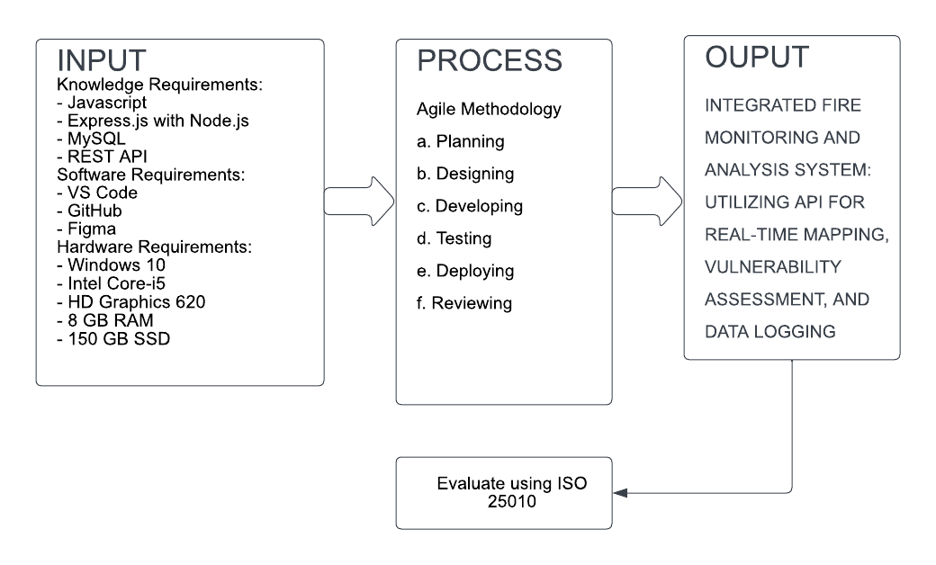

**Figure 1.** Conceptual Framework

Figure 1 shows the conceptual framework of the study consisting of input, process, and output. In input, the knowledge requirements refer to the skill or knowledge to develop the application using the technologies JavaScript, Express with Node.js runtime environment, MySQL for database management and REST API. For software requirements, Visual Studio Code IDE will be used to develop the platform, GitHub for coding collaboration, and FIGMA to design the wireframe and mockup of the platform. And for the hardware requirement, a computer with specs of Windows 10, an Intel Core i5 CPU, GeForce GPU, 8GB RAM, and 150 SSD,

In the process, the researchers will use an Agile methodology with six phases: Planning, where goals, scope, and timelines are defined; Design, referring to the development of specifications and prototypes; Development, involving coding and integration of components; Testing, for validating functionality and performance; Deployment, concerning the installation and configuration of the application; and Review, which entails evaluating effectiveness and gathering feedback.

And the output is an application program interface and an algorithm that identifies the risk level of every area in Cavite Province.

# **REVIEW OF RELATED LITERATURES**

This chapter presents the related literature and studies after the thorough and in-depth search done by the researchers. The studies included here are done both abroad and locally, which will help the researchers shape and broaden the study.

## **Foreign Studies**

**Earth Observation Science and Applications for Risk Reduction and Enhanced Resilience in Hindu Kush Himalaya Region**

Thapa et al. (2021) present a comprehensive exploration of forest fire detection and monitoring in the Hindu Kush Himalaya Region. The chapter, part of the book "Earth Observation Science and Applications for Risk Reduction and Enhanced Resilience in Hindu Kush Himalaya Region," focuses on the practical experience derived from SERVIR. The authors discuss a web portal/application developed by ICIMOD, utilizing MODIS as source of fire data. This system offers a map service, allowing the visualization of fire incidents across various administrative levels. The portal also incorporates a damage-assessment form in Nepali, enabling authorized users to record fire-related damages. Notably, the system triggers SMS and email alerts upon fire detection. This literature provides valuable insights into the integration of Earth observation technologies for effective forest fire management, emphasizing the application of satellite data in real-world scenarios.

**GIS-based urban village regional fire risk assessment and mapping**

Hermawan, Warlina, and Mohd (2021) identified home fire incidents, assessed fire danger levels, and mapped the risk level in Bandung City, Indonesia, using a geographic information system (GIS) analysis approach and direct observation of the research area. The researchers took a spatial method to analyze fire risk in the residential area, mapping urban-village regional fire occurrences and assessing the risk level using GIS. Vulnerability factors, on the other hand, are based on the sociological features of the community: population density, proportion of old age and children under five, persons with disabilities, and the population's sex ratio. According to the findings, three neighborhood units are at high danger of fire, eight are at moderate risk, and nine are at low risk.

**Integrated Satellite System for Fire Detection and Prioritization**

According to a study by Mazzeo et al. (2022), an Integrated Satellite System (ISS) for fire detection and prioritization was introduced. This system leverages data from the Moderate Resolution Imaging Spectroradiometer (MODIS), among other instruments, and incorporates the Robust Satellite Techniques (RST) and the newly structured Fire Danger Dynamic Index (FDDI). The ISS provides near real-time, integrated information on fire presence and danger in formats suitable for Geographic Information System (GIS) technologies.

Results from concurrent winter and summer fires in Italy, validated against independent sources, demonstrate that the ISS can significantly aid in fire prioritization, potentially reducing the impact on populated areas, infrastructure, and the environment.

**Research of Forest Fire Points Detection Method Based on MODIS Active Fire Product**

According to Jie Wang, Guanghui Wang, Jianwei Qi, Yu Liu, and Wei Zhang, this study introduces a forest fire detection method using MODIS active fire products, enhanced with factors like Normalized Difference Vegetation Index (NDVI), slope, and elevation.

Using data from China in July 2018, the method achieved an identification accuracy of 88.94% and a missing detection rate of 4.25%, with errors mainly due to MODIS's low spatial resolution. The method's overall accuracy was deemed satisfactory for real-time early warning. The study also analyzed a forest fire in Qinyuan County, Shanxi Province, demonstrating how identified fire points can aid in monitoring and firefighting planning, providing a scientific basis for forest fire management.

**Characterization of Spatial-Temporal Distribution of Forest Fire in Chhattisgarh, India, Using MODIS-Based Active Fire Data**

Analyzing 17 years of MODIS data, this study by Tapas Ray, Dinesh Malasiya, Akshkumar Verma, Ekta Purswani, Asif Qureshi, Mohammed Latif Khan, and Satyam Verma explores forest fire trends in Chhattisgarh, India, a region prone to such incidents but lacking comprehensive studies. Results reveal an increasing trend, with the highest occurrences in 2017 and 2009, primarily in deciduous broadleaf forests and savannas. March to May sees peak activity, with a hotspot in the southwest. The study underscores the need for tailored fire management strategies to mitigate environmental and societal impacts.

**Real-Time Wildfire Detection Algorithm Based on VIIRS Fire Product and Himawari-8 Data**

This study by Zhang, D., Huang, C., Gu, J., Hou, J., Zhang, Y., Han, W., Dou, P., and Feng, Y. (2023) focuses on constructing a fire detection model using VIIRS (Visible Infrared Imaging Radiometer Suite) data.

Using the stable VNP14IMG fire product, the authors developed a fire label dataset and employed a random forest (RF) model for fire detection with Himawari-8 multiband data. The model incorporated features such as brightness temperature, spatial features, and auxiliary data. A recursive feature elimination method was used to optimize the model by excluding redundant features.

Separate RF models for daytime (RF-D) and nighttime (RF-N) were constructed to evaluate their effectiveness. The RF models outperformed the Japan Aerospace Exploration Agency (JAXA) wildfire product, with recall and precision rates of 95.62% and 59%, respectively. The RF-D model demonstrated higher fire detection accuracy than the RF-N model, especially for small fires.

Overall, the VIIRS-based fire detection model shows excellent real-time monitoring capabilities and high detection accuracy for small fires, making it a valuable tool for wildfire management (Zhang et al., 2023).

**Monitoring Trends in Global Vegetation Fire Hot Spots Using Modis Data**

According to the study by C. Sudhakar Reddy and N. Sarika, hot spot trends in global vegetation fires were identified based on 10 years of MODIS fire data. They analyzed fire hot spots across climate zones, global land cover, and biodiversity hot spots. Using spatial statistics and space–time pattern mining, they found no significant trends in vegetation fires from 2011 to 2020. Intensifying hot spots (38.1%) were most common, followed by consecutive (30.5%), persistent (14.2%), sporadic (6.2%), oscillating (4.6%), and new hot spots (3.5%). Africa, dominated by tropical savanna and hot semi-arid climates, had the highest fire hot spot area. The study suggests standardizing techniques for identifying vulnerable zones in near real-time, predicting fire risk areas, and evaluating management effectiveness for climate change mitigation and conservation policies.

**Development of Forest Fire Risk Map Using Geographical Information Systems and Remote Sensing Capabilities: Ören Case**

Mehtap Ozenen Kavlak, Saye Nihan Cabuk, and Mehmet Cetin conducted a study in Turkey where they created a forest fire risk map for the Kütahya-Ören region using GIS analysis. The study identified very-high, high, moderate, and low-risk zones, with 36.86%, 60.39%, and 2.76% of the area falling into these categories, respectively. Additionally, visibility analysis for existing fire towers revealed that 82.8% of the region was visible from these towers.

In the Ören-Çamdibi region, remote sensing methods were utilized to detect burned areas in October 2001, which were officially recorded as 4 hectares. The study found the actual burned area to be 5.6 hectares, with 83% classified as moderate-risk areas and 17% as very-high and high-risk zones according to the fire risk map.

**A GIS and AHP-Based Approach To Map Fire Risk: A Case Study Of Kuan Kreng Peat Swamp Forest, Thailand**

Forest fires pose significant challenges to natural ecosystems, requiring proactive prevention measures. In the study conducted by Nuthammachot and Stratoulias (2021), Geographic Information System (GIS) and Analytical Hierarchy Process (AHP) were combined to analyze fire risk factors such as climate, topography, and human influence. Focusing on a peat swamp forest area in Kuan Kreng, Nakorn Sri Thammarat province, Thailand, the research categorized fire risk into five levels. Validation using 705 historic fire events from 2006 to 2017 showed that 82% occurred in the highest risk categories, with minimal omission errors. This integrated GIS and AHP approach offers valuable fire risk maps for future planning and management of fire-prone areas.

**Application of GIS and AHP Method in Forest Fire Risk Zone Mapping: A Study of the Parambikulam Tiger Reserve, Kerala, India**

In the study conducted by S. Nikhil, Jean Homian Danumah, Sunil Saha, Megha K. Prasad, A. Rajaneesh, Pratheesh C. Mammen, R. S. Ajin, & Sekhar L. Kuriakose, forest fires in the Western Ghats region, particularly in protected areas like the Parambikulam Tiger Reserve, pose significant threats. Their research aims to delineate fire risk zones using GIS techniques and assess factors influencing fire initiation. Factors such as land cover types, slope angle, aspect, and proximity to settlements, roads, tourist spots, and anti-poaching camps are analyzed. The study employs the Analytical Hierarchy Process to determine weights and utilizes ArcGIS and ERDAS Imagine software for mapping. Five risk zones—very low, low, moderate, high, and very high—are delineated. Validation using fire incidence data from 2002 to 2020 shows that 71% of fires occur in high-risk and very high–risk zones. Receiver operating characteristic curve analysis confirms the accuracy of the risk zone map. This map can guide forest planners, officials, and disaster management departments in implementing mitigation measures to safeguard valuable forest resources.

## **Local Studies**

**Visualization and Geo-Mapping of Philippine Fire Incidents**

Oñate (2022) developed a program called FireStatPH. The researcher used statistics data on Philippine Nationwide Fire Incidents provided by the Bureau of Fire Protection through Open Data Philippines from 2012 to 2016 to investigate the importance of data visualization and analysis in extracting useful information that may aid planning and decision-making. For UI and UX design, FireStatPH was built with HTML, CSS, and Javascript, while open-source Javascript libraries like as Leaflet JS are utilized to easily generate various data visualization approaches, including maps. The software displays a line graph of previous year's fire incidences as well as a choropleth map to discover which areas were the most damaged in past years.

**Mapping And Assessment of Slash-And-Burn Farming In Palawan, Philippines Using Various Fire And Burnt Area Products**

According to C. P. I. Canlas and A. C. Blanco in their study, slash-and-burn agriculture, also known as kaingin, involves clearing and burning forests for agriculture. This practice leads to forest destruction, grassland fires, soil degradation, erosion, and landslides. Using data from various sources like FIRMS and MODIS, their study examined fire patterns in Palawan from 2015 to 2022. Results show peak burning in April and March during the dry season, with a decline in fire counts in 2021 and 2022 due to La Niña. Fire incidents were found mainly in shrublands and open forests, with varying intensities and durations. High fire occurrence was noted in municipalities like Sofronio Espanola, Bataraza, and Rizal. Combining fire data aids in understanding fire characteristics for effective management strategies.

**Mapping Forest Vulnerability to Fire and Landslides in the Cordillera Region, Philippines**

From the study by Daipan, Bernard Peter & Racelis, Diomedes. (2023), forest fires are a significant threat to the Cordillera's forests, yet their vulnerability has been overlooked in previous studies. To address this gap, this study uses satellite imagery to identify fire-prone areas. In 2021, the region's forest cover spans 1.35 million hectares, but approximately 8.5% of this area is susceptible to fires. The study observes a rising trend in fire incidents and burned areas, likely due to increasing temperatures and prolonged droughts. Future projections suggest more severe fires and larger burned areas due to temperature increases and decreased precipitation. These findings underscore the need for urgent action to prevent further forest degradation from both human and natural causes.

Mayon Volcano, located on eastern Luzon Island, is the most active volcano in the Philippines and poses a significant threat to nearly one million people living in the surrounding eight cities and municipalities. This highlights the urgent need for reliable and affordable long-term volcano monitoring methods.

**Development of a Records Management System with GIS Integration: Enabling Tool for Disaster Risk Management**

From the study conducted by Madelyn B. Manun-og, Mondani R. Manun-og, Adonis Rey F. Wales, Danilo A. Balili, and Jake N. Togonon from the Southern Leyte State University-Hinunangan developed a system to enhance records management and disaster response for the Bureau of Fire Protection in Hinunangan municipality. The system includes a geographic information system for monitoring establishments during fire and disaster incidents. Development followed the iterative waterfall approach of the System Development Life Cycle (SDLC). Post-deployment, the system underwent a month-long user testing phase using test scripts and was evaluated based on the ISO 9126-1 software quality model standard. Users from the Bureau of Fire Protection reported significant improvements in records management and disaster response services.

**Multiscale And Multitemporal Surface Temperature Monitoring by Satellite Thermal Infrared Imagery at Mayon Volcano, Philippines**

In a study conducted by Hai-Po Chan and Kostas I. Konstantinou in 2020, they analyze nineteen years of Land Surface Temperature (LST) data from ASTER and MODIS satellite images. Using Ensemble Empirical Mode Decomposition (EEMD), they identify patterns in the LST data that correlate with Mayon's eruptions. Specifically, the regularity of the annual LST cycle tends to break down following an eruption, indicating volcanic restlessness. Trends suggest that Mayon will remain active in the coming decades, demonstrating the effectiveness of satellite remote sensing for volcanic monitoring.

**Benguet Forest Fire Burned Area & Taal Ash Extent Estimation Using Support Vector Machine & Thresholding Techniques**

This study, conducted by Arlo Jayson Sabuito, Cara Patricia Canlas, Mark Jayson Felix, and Gay Jane Perez, highlights the effectiveness of Diwata-2, the Philippines' second microsatellite, in disaster assessment and environmental monitoring. Since its launch in October 2018, Diwata-2 has captured 25,811 images for various applications.

The study focuses on Diwata-2's ability to monitor large-scale disasters by identifying ashfall areas from the Taal Volcano eruption and forest fire-affected areas in Benguet. Using images from January and February 2020, the extent of the damage from these events was measured. Ashfall from the Taal eruption covered approximately 20,359.64 to 55,669.24 hectares, while the Benguet forest fire affected about 2,714.59 hectares. The findings align closely with data from higher-resolution Sentinel-2 imagery, demonstrating the satellite's effectiveness despite occasional cloud cover.

Overall, the study underscores the importance of remote sensing in disaster response, providing essential spatial data for emergency actions, damage assessment, and policymaking. Future research will include field validations to enhance these insights.

**Utilizing Historical Satellite Data for Spatiotemporal Detection of Disaster-related Anomalies**

This research utilizes high-resolution satellite data to analyze historical patterns in urban areas affected by disasters. It focuses on VIIRS SNPP day/night bands VNP46A1 and VNP46A2, employing preprocessing and transformation techniques to convert satellite images into a pixel-based time series dataset. Baseline models are developed using progressive harmonic modeling based on one-year lag data and three-month progression parameters. Anomaly detection is performed using fbprophet, with a 120-day time lag determining the interval width. The algorithm effectively identifies anomalous values, which are then correlated with significant local events such as severe flooding and earthquakes. This study demonstrates the algorithm's potential for extracting valuable insights from extensive historical satellite datasets, emphasizing its practical applications (Carcellar III & Nagai, 2023).

**A Spatiotemporal Analysis of Fire Incidents in Pampanga Province of Philippines: Inputs for Fire Prevention Programs**

In their study, Aileen P. de Leon and John Paul P. Miranda examined fire incidents from 2013 to 2020 in Pampanga. They analyzed data from the Fire Bureau to map where and when fires occurred, identifying key patterns. Their findings indicate that fires are more likely to occur on Sundays and Mondays in urban areas such as Angeles, Mabalacat, and San Fernando, particularly in March and December, predominantly between 2:00-3:00 PM. Additionally, they observed a correlation between flood-prone areas and higher incidences of fires. This spatiotemporal analysis provides valuable insights for enhancing fire prevention strategies and planning in the region.

**Temporal Analysis and Geo-Mapping of Fire Incidents in the City of Manila**

Fire incidents are costly and often preventable. This study focuses on analyzing fire data in Manila from 2011 to 2014, focusing on different causes of fires. Using temporal analysis and geo-mapping techniques, the study identifies patterns based on time, day, month, and year. The analysis included 2,316 fire incidents, revealing that faulty electrical connections between 6 PM and 9 PM recorded the highest number of incidents. Daily patterns showed consistent trends, while monthly analysis indicated more fires during summer, primarily due to faulty electrical connections. Yearly trends remained steady, with faulty electrical connections consistently causing the most fires. These findings can guide proactive fire prevention strategies and resource allocation. The study also suggests future research directions in spatial and spatiotemporal analyses.

**Datasets of Fire and Crime Incidents in Pampanga, Philippines**

From the study conducted by Miranda, J. P. P., Umali, J. M., & De Leon, A. P. (2023), datasets of fire and crime incident data were gathered from two Philippine agencies: the Bureau of Fire Protection and the Philippine National Police. These datasets were used to study fire and crime patterns in Pampanga over a specific period. Steps like data preparation and cleaning were taken to accurately map incidents and identify trends. Initial findings show that most fires are caused by rubbish, occurring predominantly in the dry season. Crime incidents peak in December and coincide with high activity periods. This data provides insights into temporal patterns of incidents in Pampanga. Future plans include merging this dataset with others for broader analysis to support decision-making.

# **METHODOLOGY**

This chapter explains various methodologies that were used in gathering data and analyzing it, which are relevant to the study. The methodologies will include areas such as the research approach and design, requirements specification, research method, and development and testing.

## **Research Approach and Design**

This study used a descriptive research design to conduct the research. This approach helps the proponents identify problems and solutions. The descriptive method allows for the collection, analysis, classification, and tabulation of gathered data.

## **Study Setting**

This study was conducted in Imus City, Cavite to gather necessary information that will help to define the problems of the resident and fire authority up to the evaluation of the system.

## **Sampling Size**

The sample size of this study is one-hundred (100) respondents from Imus City, the respondents either Imus resident, fire authority or IT professional. The respondent was selected based on their convenience to evaluate the system.

## **Sampling Technique**

The proponents used Convenience Sampling based on the availability or accessibility of respondents. However, it's important to note that convenience sampling may introduce bias since it relies on readily accessible individuals.

## **Data Gathering Instrument and Procedure**

**Online Library:** The proponents used in online libraries particularly Google Scholar to gather related studies that will support and justify the study.

**Interview:** The proponents conducted a face-to-face interview in the Bureau of Fire Protection in Imus City to define the problems facing the authority in the current system used to fire response and decision-making.

**Evaluation:** The proponents used ISO 25010 model to evaluate the application.

## **Analysis Strategy**

### **Statistical Method**

After a survey, the proponents calculated the mean scores of each criterion of ISO 25010 and then calculated the overall mean. The following is the formula to get the weighted mean:

$$x=\frac{Σfx}{N}$$

x̅ = weighted mean

N = total number of respondents

x = number of respondents

Σ = summation

## **Requirements Specification**

### **Functional Requirements**

The following requirements are the requirements for the web application:

**Fire Data Querying:** Users can request fire data based on their requirements using the API endpoints.

**Data Logging:** The application automatically records fire data from FIRMS, filtering, collecting, and storing it in the database.

**Risk Assessment Algorithm:** The application calculates the risk level of each detected fire within 24 hours using historical data.

**User Registration and Authentication:** Admin can register an account with valid credentials and log in securely with correct credentials.

### **Hardware Requirements**

Table 1. The minimum and recommended specification of computer for the application

|  |  |  |
| --- | --- | --- |
| **ITEM** | **MINIMUM**  **SPECIFICATION** | **RECOMMENDED**  **SPECIFICATION** |
| Operating System  CPU  GPU  Memory  Disk Drive | Windows 7  Intel Core-i5  HD Graphics 620  8GB RAM  150GB SSD | Windows 10  Intel Core-i5  NVIDIA GeForce 940M  12GB RAM  222GB SSD |

### **Software Requirements**

**Visual Studio Code**

Visual Studio Code is a fully integrated development environment that allows for the development of software for a number of platforms and programming languages. It has an abundance of features and tools to help developers write, debug, and deploy code more efficiently. Additionally, Visual Studio offers an easy-to-use graphical interface that allows developers to correctly design and model their systems.

**GitHub**

GitHub is a leading platform for software development and version control, enabling developers to collaborate on code seamlessly. It provides tools for project management, code review, and CI/CD automation.

**Figma**

Figma is a web-design tool used by designers to create a wireframe or mockup design for an application. Using Figma, teams can collaborate, contribute to a specific project, and share their ideas in real-time through a shared file or link that all teams can access. There are many interesting features of Figma that will make designing easier, such as shapes, frames, plugins, templates, and many more. This can save more time, effort, and money.

## **Research Method**

### **Materials**

For the development of the application, the developer used a computer system with a 64-bit Intel Core i5 processor, an NVIDIA GeForce 940M, and 4 gigabytes of RAM.

### Method

Agile is a popular project management method in software development. It breaks down projects into phases and emphasizes continuous improvement and collaboration. The proponent used an Agile framework called Agile Scrum Methodology which is a popular agile framework created by Jeff Sutherland and Ken Schwaber.

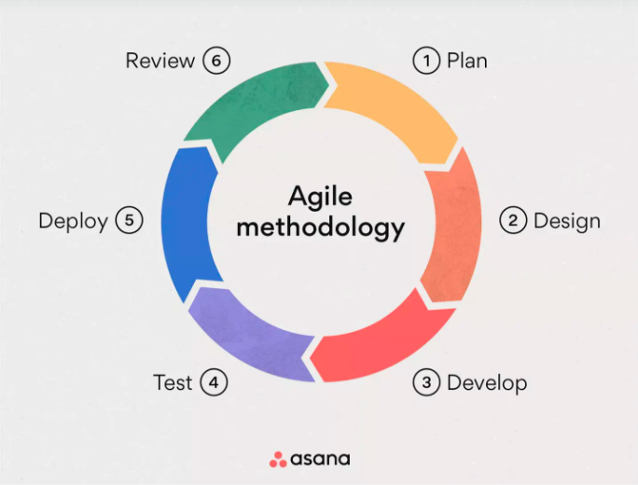

**Figure 2.** Agile Methodology (Beck et al., 2001)

**Planning:** The proponents gather information by conducting an interview to define the problems and to identify the requirements needed for the system to solve the problem of the organization.

**Designing:** After planning and having the requirements, the next phase is designing wherein the prototype system is being designed using Figma to visualize the appearance or features of the system including here the software architecture.

**Developing:** Using the IDEs and knowledge in programming languages such as Javascript, Express, REST API, etc., in this phase, the system is being developing.

**Testing:** Once, the system has now fully developed, it must undergo with further verification and testing to ensure that the system works accordingly. This is required to identify error by debugging or fixing it.

**Deploying:** In this phase, the system is now ready to deploy to the selected user after several verification and testing ensuring no error will interrupt the functionalities of the system but the developers still need to update and maintain the system such as adding new features, fixing bug, etc.

**Reviewing:** After deployment, the developers will need to review the system to ensure that all the requirements are met and that it is working properly and accordingly. This phase will minimize the possible problems you may encounter in the launch phase.

## **Development and Testing**

### **Project Schedule**

**Table 2.** Gantt Chart

|  |  |  |  |  |  |  |  |  |  |
| --- | --- | --- | --- | --- | --- | --- | --- | --- | --- |
| Process | Jan. 2024 | | Feb. 2024 | | Mar. 2024 | April 2024 | May 2024 | June 2024 | |
| Planning |  | |  | |  |  |  |  | |
| Designing |  |  |  |  |  |  |  |  | |
| Developing |  | |  |  |  |  |  |  | |
| Testing |  | |  | |  |  |  |  | |
| Deploying |  | |  | |  |  |  |  |  |
| Reviewing |  | |  | |  |  |  |  |  |

Table 2 shows the processes undertaken to conduct this study, which include the phases of the Agile methodology along with their completion timeframes.

## **Operations and Testing Procedures**

The following are the operations and tests of the application for user:

1. Users open the application to monitor fire in Cavite, if there’s fire detected, it displays fire data information.
2. Users select Cavite or Local Government Unit to focus the map to a particular area.
3. Users view the risk index map to determine the risk level of local government units in Cavite.
4. Users view the record of fire in Cavite and select city or municipality, instrument, year and confidence level to retrieve data.
5. Users view the API documentation
6. Users view the frequently asked question to understand the system.
7. Users close the application.

The following are the operations and tests of the application for admin:

1. Admin registers an account.
2. Admin login to the application.
3. Admin request data from Fire Resource Information Monitoring System.
4. Admin logout from the application.

## **Evaluation Criteria**

The following criteria will be used to evaluate the system based on the ISO 25010:

**Functionality Suitability** - The degree to which a system's functions cover all specified tasks and user objectives, provide correct results with necessary precision, and facilitate the accomplishment of specified tasks and objectives.

**Performance Efficiency** - The degree to which a system meets its performance requirements with optimal use of time, resources, and capacity.

**Compatibility** - The degree to which a system can operate effectively within a shared environment and interact with other systems.

**Usability** - The degree to which a system or product can be used by specified users to achieve specific goals with effectiveness, efficiency, and satisfaction.

**Reliability** - The degree to which a system, product, or component performs its required functions under stated conditions for a specified period.

**Security** - The degree to which a system, product, or component protects data and maintains functionality as intended, safeguarding against unauthorized access and modifications.

**Maintainability** - The ease with which a system or component can be modified, adapted, or repaired to ensure it continues to perform as intended.

**Portability** - The ease with which a system or component can be transferred from one environment to another.

**Table 3**. Numerical scale and interpretation to evaluate the system using Likert-Scale

|  |  |
| --- | --- |
| **NUMERICAL SCALE** | **INTERPRETATION** |
| 1  2  3  4  5 | Needs Improvement  Fair  Good  Very Good  Excellent |

**Table 4.** Interpretation based on the range of the mean score.

|  |  |
| --- | --- |
| **NUMERICAL SCALE** | **INTERPRETATION** |
| 1.00 – 1.50  1.51 – 2.50  2.51 – 3.50  3.51 – 4.50  4.51 – 5.00 | Excellent  Very Good  Good  Acceptable  Highly Acceptable |

## **Evaluation Procedure**

The proponents selected respondents based on their convenience to evaluate the application using the criteria of ISO 25010. The following procedures must be followed:

* The proponents introduced the application and taught the respondents how to use it.
* After the introduction and teaching, the proponents gave an evaluation form to the respondents in Imus City.
* After the evaluation, the proponents collected the answer forms and calculated them to obtain the final result.

# **RESULTS AND DISCUSSION**

This chapter presents the results of evaluating the application. Using an online evaluation form, one hundred (100) responses were analyzed. The evaluation process followed ISO 25010 standards, utilizing the mean formula to calculate the overall average.

## **RESULTS**

**Table 5.** Profile of respondents based on the type of evaluator

|  |  |  |
| --- | --- | --- |
| **TYPE OF EVALUATOR** | **NUMBER OF RESPONDENT** | **PERCENTAGE (%)** |
| Imus resident  Fire fighter  IT professional  **TOTAL** | 73  11  16  **100%** | 73%  11%  16%  **100%** |

In Table 5, the total number of respondents and their evaluator types are displayed, showing a breakdown by percentage. The majority of responses originated from Imus residents, totaling seventy-three respondents, representing 73% of the total population surveyed. Additionally, 11% of the respondents identified as firefighters, while 16% identified as IT professionals.

### **General Rating in FUNCTIONALITY SUITABILITY**

**Table 6.** General Rating of Integrated Fire Monitoring and Analysis System: Utilizing API for Real-Time Mapping, Vulnerability Assessment, and Data Logging in terms of Functionality Suitability.

|  |  |  |
| --- | --- | --- |
| **FUNCTIONALITY SUITABILITY** | **MEAN SCORE** | **INTERPRETATION** |
| FUNCTIONAL COMPLETENESS.  The application covers all the specified tasks and user objectives. | 3.93 | Acceptable |
| FUNCTIONAL CORRECTNESS.  The application provides the correct results with the needed degree of precision. | 4.2 | Acceptable |
| FUNCTIONAL APPROPRIATENESS.  The application functions facilitate the accomplishment of specified tasks and objectives. | 3.98 | Acceptable |
| **Weighted Mean** | **4.04** | **Acceptable** |

Table 6 highlights significant findings. Functionality Completeness, rated acceptable with a mean score of 3.93, ensures adequate coverage of specified tasks and objectives. Functionality Correctness, also rated acceptable (mean score: 4.2), delivers precise results as required. Moreover, Functionality Appropriateness earns an acceptable rating (mean score: 3.98), facilitating effective task accomplishment. The weighted mean of 4.04 confirms the overall functionality suitability. In summary, across these criteria, the system demonstrates satisfactory performance, meeting the expected standards for completeness, correctness, and appropriateness.

### **General Rating in PERFORMANCE EFFICIENCY**

**Table 7.** General Rating of “Integrated Fire Monitoring and Analysis System: Utilizing API for Real-Time Mapping, Vulnerability Assessment, and Data Logging” in terms of Performance Efficiency.

|  |  |  |
| --- | --- | --- |
| **PERFORMANCE EFFICIENCY** | **MEAN SCORE** | **INTERPRETATION** |
| TIME BEHAVIOUR.  The application's response and processing times, as well as its throughput rates when performing its functions, meet requirements. | 4.09 | Acceptable |
| RESOURCE UTILIZATION.  The application ensures that the amounts and types of resources used when performing its functions meet requirements. | 4.06 | Acceptable |
| CAPACITY.  The application ensures that the maximum limits of a product or system parameter meet requirements. | 3.97 | Acceptable |
| **Weighted Mean** | **4.04** | **Acceptable** |

Table 7 displays impressive performance across key metrics. Time Behavior earns an acceptable rating (mean score: 4.09), indicating meeting required standards for response and processing times. Resource Utilization achieves an acceptable rating (mean score: 4.06), showcasing efficient management of resources. Additionally, Capacity receives an acceptable rating (mean score: 3.97), affirming alignment with maximum system parameter limits. The weighted mean of 4.04 reinforces overall performance efficiency. In summary, the system demonstrates satisfactory performance in time behavior, resource utilization, and capacity, meeting necessary standards for efficient operation.

### **General Rating in COMPATIBILITY**

**Table 8.** General Rating of “Integrated Fire Monitoring and Analysis System: Utilizing API for Real-Time Mapping, Vulnerability Assessment, and Data Logging” in terms of Compatibility.

|  |  |  |
| --- | --- | --- |
| **COMPATIBILITY** | **MEAN SCORE** | **INTERPRETATION** |
| CO-EXISTENCE.  The application can efficiently perform its required functions while sharing a common environment and resources with other applications, without detrimental impact on any other application. | 4.06 | Acceptable |
| INTEROPERABILITY.  The application facilitates the exchange of information between two or more systems, products, or components, allowing them to utilize the exchanged information effectively. | 3.82 | Acceptable |
| **Weighted Mean** | **3.94** | **Acceptable** |

Table 8 shows satisfactory performance. Co-existence achieves a mean score of 4.06, indicating effective function within shared environments with minimal impact on other applications. Interoperability receives an acceptable rating, scoring a mean of 3.82, showing its effectiveness in facilitating the exchange of information among multiple systems. The overall compatibility, with a weighted mean of 3.94, confirms the application's ability to work smoothly alongside other applications and exchange information seamlessly.

### **General Rating in USABILITY**

**Table 9.** General Rating of “Integrated Fire Monitoring and Analysis System: Utilizing API for Real-Time Mapping, Vulnerability Assessment, and Data Logging” in terms of Usability.

|  |  |  |
| --- | --- | --- |
| **USABILITY** | **MEAN SCORE** | **INTERPRETATION** |
| APPROPRIATENESS RECOGNIZABILITY.  Users can determine if the application or system is suitable for their needs. | 3.74 | Acceptable |
| LEARNABILITY.  The application or system can be effectively used by specified users to achieve predefined learning goals, ensuring effectiveness, efficiency, safety, and satisfaction within a specified context of use. | 4.07 | Acceptable |
| OPERABILITY.  The application or system possesses attributes that facilitate ease of operation and control. | 3.89 | Acceptable |
| USER ERROR PROTECTION.  The application or system safeguards users from making errors. | 3.84 | Acceptable |
| USER INTERFACE AESTHETICS.  The user interface provides a pleasing and satisfying interaction experience for the user. | 3.8 | Acceptable |
| ACCESSIBILITY.  The application or system accommodates users with diverse characteristics and capabilities, enabling them to achieve a specified goal within a specified context of use. | 3.89 | Acceptable |
| **Weighted Mean** | **3.87** | **Acceptable** |

Table 9 indicates that the application performs adequately across various usability aspects. Users can effectively determine its suitability (3.74), learn to use it efficiently (4.07), operate it easily (3.89), and are protected from errors (3.84). Additionally, user interface aesthetics and accessibility are considered acceptable. Overall, with a weighted mean of 3.87, the application demonstrates satisfactory usability, meeting user needs and expectations effectively.

### **General Rating in RELIABILITY**

**Table 10.** General Rating of Integrated Fire Monitoring and Analysis System: Utilizing API for Real-Time Mapping, Vulnerability Assessment, and Data Logging” in terms of Reliability.

|  |  |  |
| --- | --- | --- |
| **RELIABILITY** | **MEAN SCORE** | **INTERPRETATION** |
| MATURITY.  The application meets the needs for reliability under normal operation. | 4.17 | Acceptable |
| AVAILABILITY.  The application is operational and accessible when required for use. | 4.02 | Acceptable |
| FAULT TOLERANCE.  The application operates as intended despite the presence of hardware or software faults. | 3.92 | Acceptable |
| RECOVERABILITY.  The application can recover the data directly affected and re-establish the desired state of the system in the event of an interruption or failure | 3.75 | Acceptable |
| **Weighted Mean** | **3.96** | **Acceptable** |

Table 10 demonstrates acceptable reliability across key metrics. It reliably meets operational needs (Maturity: 4.17) and remains accessible when needed (Availability: 4.02). Despite faults, it continues to operate as intended (Fault Tolerance: 3.92). Additionally, it shows acceptable recoverability capabilities. Overall, with a weighted mean of 3.96, the application's reliability is deemed acceptable.

### **General Rating in SECURITY**

**Table 11.** General Rating of “Integrated Fire Monitoring and Analysis System: Utilizing API for Real-Time Mapping, Vulnerability Assessment, and Data Logging” in terms of Security.

|  |  |  |
| --- | --- | --- |
| **SECURITY** | **MEAN SCORE** | **INTERPRETATION** |
| CONFIDENTIALITY.  The application ensures that data are accessible only to those authorized to have access. | 3.94 | Acceptable |
| INTEGRITY.  The application prevents unauthorized access to, or modification of, computer programs or data. | 3.77 | Acceptable |
| NON-REPUDIATION.  Within the application, actions or events can be proven to have taken place, ensuring that they cannot be denied or repudiated later. | 3.8 | Acceptable |
| ACCOUNTABILITY.  The actions of an entity within the application can be uniquely traced back to that entity. | 3.68 | Acceptable |
| AUTHENTICITY.  The application can prove that the identity of a subject or resource is as claimed. | 3.73 | Acceptable |
| **Weighted Mean** | **3.98** | **Acceptable** |

Table 11 demonstrates acceptable security across various aspects. It ensures data access only to authorized users (Confidentiality: 3.94) and prevents unauthorized access or modification (Integrity: 3.77). Actions within the application can be proven and not denied later (Non-repudiation: 3.8). Additionally, it enables tracing actions to entities (Accountability: 3.68) and verifies the identity of subjects or resources (Authenticity: 3.73). With a weighted mean of 3.98, the overall security is considered acceptable.

### **General Rating in MAINTAINABILITY**

**Table 12.** General Rating of “Integrated Fire Monitoring and Analysis System: Utilizing API for Real-Time Mapping, Vulnerability Assessment, and Data Logging” in terms of Maintainability.

|  |  |  |
| --- | --- | --- |
| **MAINTAINABILITY** | **MEAN SCORE** | **INTERPRETATION** |
| MODULARITY. The application is composed of discrete components so that a change to one component has minimal impact on other components. | 3.91 | Acceptable |
| REUSABILITY.  The application can be used in more than one system or in building other applications. | 3.83 | Acceptable |
| ANALYSABILITY.  The application's ability to effectively and efficiently assess changes, diagnose issues, and identify parts that need modification. | 3.76 | Acceptable |
| MODIFIABILITY.  The application can be effectively and efficiently modified without introducing defects or degrading existing product quality. | 3.65 | Acceptable |
| TESTABILITY. Test criteria can be established for an application, and tests can be performed to determine whether those criteria have been met. | 3.69 | Acceptable |
| **Weighted Mean** | **3.97** | **Acceptable** |

Table 12 demonstrates acceptable maintainability across various criteria. It allows for changes with minimal impact on other components (Modularity: 3.91) and can be reused in different systems (Reusability: 3.83). It effectively assesses changes and diagnoses issues (Analyzability: 3.76). Additionally, it can be modified without introducing defects (Modifiability: 3.65) and tested against established criteria (Testability: 3.69). With a weighted mean of 3.97, overall maintainability is considered acceptable.

### **General Rating in PORTABILITY**

**Table 13.** General Rating of “Integrated Fire Monitoring and Analysis System: Utilizing API for Real-Time Mapping, Vulnerability Assessment, and Data Logging” in terms of Portability.

|  |  |  |
| --- | --- | --- |
| **PORTABILITY** | **MEAN SCORE** | **INTERPRETATION** |
| ADAPTABILITY.  The application can effectively and efficiently be adapted for different or evolving hardware, software or other operational or usage environments. | 4.03 | Acceptable |
| INSTALLABILITY.  The application can be successfully installed and/or uninstalled in a specified environment. | 3.91 | Acceptable |
| REPLACEABILITY.  The application can replace another specified software product for the same purpose in the same environment. | 3.64 | Acceptable |
| **Weighted Mean** | **3.86** | **Acceptable** |

Table 13 shows acceptable portability across key metrics. It can effectively adapt to different environments (Adaptability: 4.03) and be successfully installed and uninstalled (Installability: 3.91). Additionally, it can replace other software products in the same environment (Replaceability: 3.64). With a weighted mean of 3.86, overall portability is deemed acceptable.

### **OVERALL RATING OF THE APPLICATION**

**Table 14.** Overall Mean of the Evaluation

|  |  |  |
| --- | --- | --- |
| **INDICATOR** | **WEIGHTED MEAN** | **INTERPRETATION** |
| Functionality Suitability | 4.04 | Acceptable |
| Performance Efficiency | 4.04 | Acceptable |
| Compatibility | 3.94 | Acceptable |
| Usability | 3.87 | Acceptable |
| Reliability | 3.96 | Acceptable |
| Security | 3.98 | Acceptable |
| Maintainability | 3.97 | Acceptable |
| Portability | 3.86 | Acceptable |
| Mean Total | 3.96 | Acceptable |

Table 14 shows the overall mean evaluation of the system is 3.96, deemed Acceptable. This indicates satisfactory performance across key dimensions, including functionality, efficiency, compatibility, usability, reliability, security, maintainability, and portability. Each individual indicator also achieves acceptable ratings, ranging from 3.86 to 4.04. Therefore, the system meets necessary standards for its intended purpose.

The overall mean evaluation of the application is 3.96, considered acceptable. This indicates satisfactory performance on the functionality, efficiency, compatibility, usability, reliability, security, maintainability, and portability, each achieved acceptable ratings, ranging from 3.86 to 4.04. Therefore, the application meets necessary standards for its intended purpose.

In functionality, with mean scores of 3.93 for completeness, 4.2 for correctness, and 3.98 for appropriateness, resulting in an overall weighted mean of 4.04. It meets expected standards for task coverage, precision, and effectiveness. In performance efficiency with mean scores of 4.09 for time behavior, 4.06 for resource utilization and 3.97 for capacity, giving an overall weighted mean of 4.04. It means it meets the required standards for response times, efficient resource management, and system parameter limits, ensuring efficient operation. In compatibility, co-existence scores 4.06, indicating effective function in shared environments with minimal impact. Interoperability scores 3.82, showing effectiveness in information exchange among systems. With an overall weighted mean of 3.94, the application works smoothly alongside other applications and exchanges information seamlessly. In usability, users can determine suitability with a score of 3.74, learn to use it efficiently with a score of 4.07, operate it easily with a score of 3.89, and are protected from errors with a score of 3.84. User interface aesthetics and accessibility are acceptable. Overall, with a weighted mean of 3.87, the application satisfactorily meets user needs and expectations. In reliability, the application reliably meets operational needs with a maturity score of 4.17 and remains accessible when needed with an availability score of 4.02. Despite faults, it continues to operate as intended with a fault tolerance score of 3.92 and has acceptable recoverability capabilities. Overall, with a weighted mean of 3.96, the application's reliability is deemed acceptable. In security, the application demonstrates acceptable performance. It ensures data access only to authorized users with a confidentiality score of 3.94 and prevents unauthorized access or modification with an integrity score of 3.77. It also supports non-repudiation with a score of 3.8, accountability with a score of 3.68, and authenticity with a score of 3.73. With a weighted mean of 3.98, the overall security is considered acceptable. In maintainability, it has a modularity score of 3.91, allowing changes with minimal impact on other components, and a reusability score of 3.83. It effectively assesses changes and diagnoses issues with an analyzability score of 3.76. Additionally, it can be modified without introducing defects with a modifiability score of 3.65 and tested against established criteria with a testability score of 3.69. With a weighted mean of 3.97, overall maintainability is considered acceptable. And in portability, the application scores 4.03, indicating its adaptability to different environments, and 3.91 for Installability. Additionally, it can replace other software products in the same environment with a Replaceability score of 3.64. With a weighted mean of 3.86, overall portability is deemed acceptable.

# **SUMMARY, CONCLUSION AND RECOMMENDATIONS**

This chapter outlines the findings and conclusions drawn by the researchers based on their study. Additionally, it offers recommendations for future investigations to enhance the study's scope and depth.

## **Summary**

The Integrated Fire Monitoring and Analysis System utilizes a custom-developed API for real-time mapping, vulnerability assessment, and continuous data logging. This API offers real-time fire monitoring with a 1-minute interval and data retrieval based on specific parameters such as year, instrument (MODIS or VIIRS), LGU, and confidence level. The system calculates the vulnerability or risk level of the new data based on the historical fire data and also continuously records the new data and stores it in the database. The Fire Information Resources Monitoring System is the source of fire data collected from the satellite instruments called MODIS and VIIRS. These instruments can be used to detect fires from space.

By leveraging the functionalities of the system, this ensures comprehensive fire management and decision-making processes, facilitating efficient monitoring, analysis, and response to fire incidents within Cavite.

In the development, the researchers used Agile methodology, specifically the Agile framework called Scrum. Agile methodology has seven (6) phases: planning, designing, developing, testing, deploying, and reviewing. Visual Studio Code was used to develop the application or program; Figma was used to design the wireframe and mockup interface of the web application; GitHub was used for coding collaboration; and Javascript was used as a programming language. The researchers used ISO 25010 for the evaluation of the system.

## **Conclusions**

In this study, researchers developed an Application User Interface (API) and Risk Assessment Algorithm to aid fire authorities and residents in Imus and throughout Cavite in monitoring fire incidents and determining the risk level of each Local Government Unit (LGU) in the region. This initiative aims to assist the community in decision-making, preparedness, mitigation, and fire prevention planning.

Utilizing expertise in developing REST APIs with Express.js, a JavaScript framework operating in the server-side environment of Node.js, alongside Visual Studio Code as the development tool, the researchers successfully created the application user interface and risk assessment algorithm. The success of this development is attributed to the application of Agile methodology, which guided the process from planning to system review.

The result of the evaluation reveals that the application is Acceptable by the participants, with an overall mean rating of 3.96. Additionally, using the ISO 25010 standard, the application was evaluated and found to have achieved its objectives, thereby meeting the criteria for quality software.

## **Recommendations**

1. Enhanced Data Integration: Include barangay names in the API response to provide more granular fire incident information.
2. Improved Data Accuracy: Integrate historical fire data from fire station records to enhance the accuracy of fire risk assessments.
3. Advanced Analytical Techniques: Incorporate machine learning models for more sophisticated fire risk assessments based on evolving data trends.
4. Predictive Capabilities: Implement forecasting models to predict potential fire incidents within a specified timeframe, aiding proactive response strategies.

# **REFERENCES**

Carcellar III, B. G., & Nagai, M. (2023). Utilizing Historical Satellite Data for Spatiotemporal

Detection of Disaster-related Anomalies. *Philippine Engineering Journal*, 44(2), 25-41. Retrieved from https://journals.upd.edu.ph/index.php/pej/article/download/9480/8374

Chan, H.-P., & Konstantinou, K. I. (2020). Multiscale and multitemporal surface temperature

monitoring by satellite thermal infrared imagery at Mayon Volcano, Philippines. *Journal of Volcanology and Geothermal Research, 401*, 106976. https://doi.org/10.1016/j.jvolgeores.2020.106976

Daipan, Bernard Peter & Racelis, Diomedes. (2023). Mapping Forest Vulnerability to Fire and

Landslides in the Cordillera Region, Philippines*.* *SciEnggJ*. 16. 265-

274.10.54645/2023162KDL-34.

de Leon, A., & Miranda, J. P. (2022). A Spatiotemporal Analysis of Fire Incidents in Pampanga,

Philippines: Inputs for Fire Prevention Programs. *International Transaction Journal of Engineering, Management, & Applied Sciences & Technologies*, 13(10), 13A10D, 1-17. Retrieved from http://TUENGR.COM/V13/13A10D.pdf DOI: 10.14456/ITJEMAST.2022.193

Mazzeo, G., De Santis, F., Falconieri, A., Filizzola, C., Lacava, T., Lanorte, A., Marchese, F.,

Nolè, G., Pergola, N., Pietrapertosa, C., & others. (2022). Integrated Satellite System for Fire Detection and Prioritization*.* *Remote Sensing*,*14(2),* 335. https://doi.org/10.3390/rs14020335

Manunog, M. B., Manunog, M. R., Wales, A. R. F., Balili, D. A., & Togonon, J. N. (2022).

Development of a records management system with GIS integration: enabling tool for disaster risk management. *Science and Engineering Journal, 15*(2), 72-77. https://scienggj.org/2022/SciEnggJ%202022-vol15-no02-p72-78-Manun-og%20et%20al.pdf

Miranda, J. P. P., Umali, J. M., & De Leon, A. P. (2023). Datasets of fire and crime incidents in

Pampanga, Philippines. *International Journal of Computing Sciences Research, 7*, 1637-1646. https://doi.org/10.25147/ijcsr.2017.001.1.121

Hermawan, Y.A., Warlina, L. & Mohd, M. (2021). GIS-based urban village regional fire risk

assessment and mapping. *International Journal of Informatics, Information System and Computer Engineering, 2(2),* 31-43. doi.org/10.34010/injiiscom.v2i2.6041

Wang, J., Wang, G., Qi, J., Liu, Y., & Zhang, W. (2021). Research of Forest Fire Points

Detection Method Based on MODIS Active Fire Product. In *2021 28th International Conference on Geoinformatics* (pp. 1-5). Nanchang, China. doi:10.1109/IEEECONF54055.2021.9687646.

Nikhil, S., Danumah, J. H., Saha, S., & et al. (2021). Application of GIS and AHP method in

forest fire risk zone mapping: A study of the Parambikulam Tiger Reserve, Kerala, India. *Journal of Geovisualization and Spatial Analysis, 5* (14).<https://doi.org/10.1007/s41651-021-00082-x>

Nuthammachot, N., & Stratoulias, D. (2021). A GIS- and AHP-based approach to map fire risk:

a case study of Kuan Kreng peat swamp forest, Thailand. *Geocarto International*, 36(2), 212–225. https://doi.org/10.1080/10106049.2019.1611946

Sabuito, A. J., Canlas, C. P., Felix, M. J., & Perez, G. J. (2020). Benguet forest fire burned area

& Taal ash extent estimation using support vector machine & thresholding techniques. In *Proceedings of the 41st Asian Conference on Remote Sensing (ACRS 2020).* Retrieved from https://a-a-r-s.org/proceeding/ACRS2020/r2nm1h.pdf

Smith, J. D., & Johnson, A. B. (2023). Mapping and assessment of slash-and-burn farming in

Palawan, Philippines using various fire and burnt area products. *Journal of*

*Environmental Science and* *Management*,15(2), 123135.https://doi.org/10.1117/12.3009667

Thapa, S., Chitale, V. S., Pradhan, S., Shakya, B., Sharma, S., Regmi, S., & Dangol, G. S.

(2021). Forest fire detection and monitoring. In *Earth Observation Science and Applications for Risk Reduction and Enhanced Resilience in Hindu Kush Himalaya Region: A Decade of Experience from SERVIR* (pp. 147-167).

Ray, T., Malasiya, D., Verma, A., Purswani, E., Qureshi, A., Khan, M. L., & Verma, S. (2023).

Characterization of spatial–temporal distribution of forest fire in Chhattisgarh, India, using MODIS-based active fire data. *Sustainability, 15*(9), 7046.<https://doi.org/10.3390/su15097046>

Reddy, C. S., & Sarika, N. (2022). Monitoring trends in global vegetation fire hot spots using

MODIS data. *Spatial Information Research, 30*(4), 617–632. [https://doi.org/10.1007/s41324-022-00457-2](http://./%20https:/doi.org/10.1007/s41324-022-00457-2)

Oñate, J.J. (2022), Visualization and Geo-Mapping of Philippine Fire Incidents, *Journal of*

*Engineering and Emerging Technologies, 1(1),* 15-23*. doi:10.52631/jeet.v1i1.121*

Ozenen Kavlak, M., Cabuk, S. N., & Cetin, M. (2021). Development of forest fire risk map using

geographical information systems and remote sensing capabilities: Ören case. *Environmental Science and Pollution Research, 28*, 33265–33291.<https://doi.org/10.1007/s11356-021-13080-9>

Zhang, D., Huang, C., Gu, J., Hou, J., Zhang, Y., Han, W., Dou, P., & Feng, Y. (2023). Real-

time wildfire detection algorithm based on VIIRS fire product and Himawari-8 data. *Remote Sensing, 15*(6), 1541.<https://doi.org/10.3390/rs15061541>

# **APPENDICES**

**Appendix 1:** Flowchart

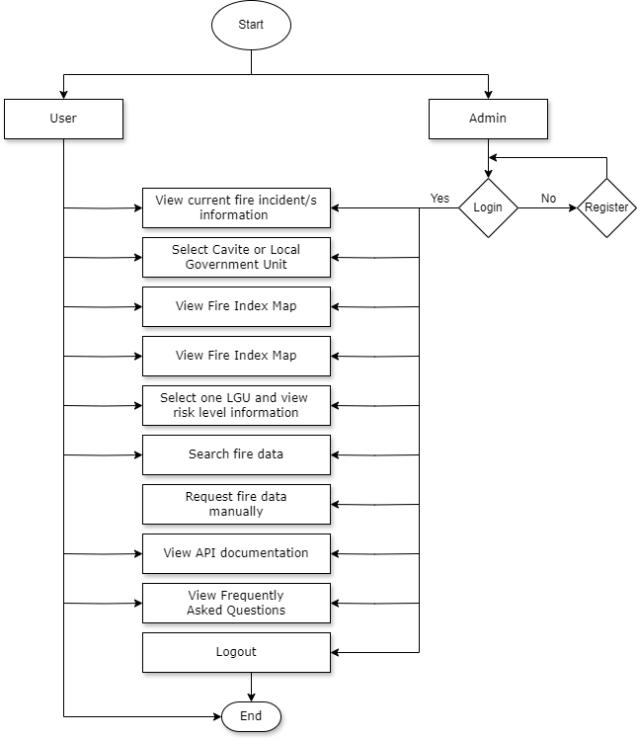

**Appendix 2:** Entity Relational Diagram

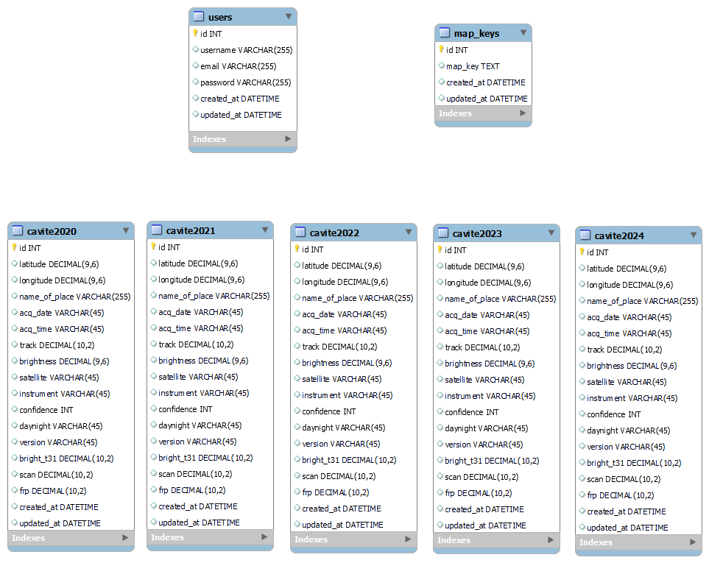

**Appendix 3:** Timetable of Activities

|  |  |  |  |  |  |  |  |  |  |
| --- | --- | --- | --- | --- | --- | --- | --- | --- | --- |
| Process | Jan. 2024 | | Feb. 2024 | | Mar. 2024 | April 2024 | May 2024 | June 2024 | |
| Planning |  | |  | |  |  |  |  | |
| Designing |  |  |  |  |  |  |  |  | |
| Developing |  | |  |  |  |  |  |  | |
| Testing |  | |  | |  |  |  |  | |
| Deploying |  | |  | |  |  |  |  |  |
| Reviewing |  | |  | |  |  |  |  |  |

**Appendix 4:** Curriculum Vitae

**Mohamad Ali Calanda**

**Full-Stack Developer**

Address : Aniban 2, Bacoor City, Cavite

Mobile No. : 09701638399

Email : [mohamadalicalanda20@gmail.com](mailto:mohamadalicalanda20@gmail.com)

Motivated aspiring web developer adept in modern technologies, passionate

about creating user-friendly web applications. Eager to contribute to dynamic

projects and grow within a collaborative team environment.

**SKILLS**

HTML, CSS, Bootstrap, jQuery, Responsive Web Design, Git, GitHub, MySQL, ERD, PHP, OOP, Model View Controller (MVC), CodeIgniter 3, Ajax, JavaScript ES5 & ES6, NodeJS, Express, ReactJS, EJS, Socket.io, Python, User Experience Design (UX), Figma, Agile (Scrum), Amazon RDS, Amazon App Runner

**INTERNSHIP**

**Quality Assurance Manual Tester (August 2023 - September 2023)**

Ollopa Corporation - Quezon City, Metro Manila

Promoted to team leader overseeing intern testing and AI project debugging.

**TRAINING**

Village88 Online Coding Training (January 8, 2024 - April 26, 2024)

Finished rigorous and intensive Full Stack Web Development Training consistently from web fundamentals to advanced level. Exam passer in all certifications and developed 2 projects.

**PROJECTS**

[**E-Commerce Website**](https://www.youtube.com/watch?v=hbaPBph0XVo) – developed to sell and buy various products. It has an admin page to add, update, and delete products and orders, and a customer page to purchase products.

[**SheetSoundSynth**](https://www.youtube.com/watch?v=zsjJxvghS-s) – a web application that can turn a music sheet image into a playable melody. The user can play the music into different instruments and save it in their account.

**AWARDS**

**Best in Capstone Certification (Village88, Inc, April 2024)** - built a solo quality capstone, a web application that converts image into playable melody within a week

**Proficient in Front-End Development (Village88, Inc., April 2024)** - passed exam in coding a tasks logger application using React for 9 hours.

**Proficient in Advanced JavaScript (Village88, Inc., March 2024) -** passed exam in coding a multiplayer application using Express and Socket.io similar to Minecraft game but in 2D for 9 hours.

**Proficient in Advanced PHP (Village88, Inc., February 2024)** - passed exam in coding an application using CodeIgniter that implements pagination for 9 hours.

**Proficient in Web Fundamentals (Village88, Inc., January 2024)** - passed exam in cloning a landing page of Home Credit website using Pure HTML and CSS for 9 hours.

**Front-End Development Certification (Village88, Inc., April 2024)** - finished front-end development track

**Advanced JavaScript Certification (Village88, Inc., March 2024)** - finished advanced JavaScript track

**Advanced PHP Certification (Village88, Inc., February 2024)** - finished advanced PHP track

**Web Fundamentals Certification (Village88, Inc., January 2024)** - finished web fundamentals track

**EDUCATION**

**Bachelor of Science in Computer Science (August 2024)**

Cavite State University - Imus Campus, Cavite

**JANNA MAY GENSAYA**

**UI / UX Designer**

Address : Buhay na Tubig, Imus, Cavite

Mobile No. : 09663128894

Email : [jannamayg@gmail.com](mailto:jannamayg@gmail.com)

Age : 24

Sex : Female

Civil Status : Single

As an enthusiastic aspiring UI/UX designer, I am driven to learn and contribute to innovative projects. Skilled in contemporary web technologies, I am dedicated to creating intuitive and engaging web experiences. I am eager for an opportunity to apply my skills, grow professionally, and add value to a collaborative team environment.

**HARD SKILLS**

HTML, CSS, GitHub, MySQL, Python, User Experience Design (UX), Figma, Canva, Microsoft Office Proficiency, Pinterest, Pixel Arts

**SOFT SKILLS**

* Dedicated,
* Hardworking,
* Responsible,
* Good Fearing,
* Respectful,
* Humble,
* Organized,
* Time Management, Adaptable

**TRAINING**

**Quality Assurance Manual Tester (August 2023 - September 2023)**

Ollopa Corporation - Quezon City, Metro Manila

* consistenly and passionately test and debug AI projects of the company.

**EDUCATION**

Secondary

Technical Vocational Livelihood – Food Processing (2016 – 2018)

Bondoc Peninsula Agricultural High School, Mulanay, Quezon

Tertiary

Bachelor of Science in Computer Science (August 2024)

Cavite State University - Imus Campus, Cavite

**SHARMINE TABUADA**

**UI / UX Designer**

Address : Mambog 3, Bacoor, Cavite

Mobile No. : 09122926284

Email : [sharmtabuada@gmail.com](mailto:sharmtabuada@gmail.com)

Age : 24

Sex : Female

Civil Status : Single

As a passionate aspiring UI/UX designer, I'm motivated to expand my knowledge and contribute to cutting-edge projects. Proficient in modern web technologies, my focus is on crafting user-friendly and captivating web interfaces. I'm enthusiastic about the chance to utilize my skills, develop professionally, and contribute positively to a team-driven atmosphere.

**HARD SKILLS**

HTML, CSS, MySQL, User Experience Design (UX), Figma, Canva, Microsoft Office Proficiency, Web Designing, Computer Literate, Digital Art

**SOFT SKILLS**

* Willing to learn
* Can work under pressure
* Respectful
* Fluent in English, Tagalog and Bisaya

**TRAINING**

**Quality Assurance Manual Tester (August 2023 - September 2023)**

Ollopa Corporation - Quezon City, Metro Manila

* consistenly and passionately test e-commerce website of the company.

**Customer Service Representative**

Master Group Philippines

**On-The-Job Trainee (15 days work immersion)**

Hotel Bay Plaza

**On-The-Job Trainee (15 days work immersion)**

Ocean View Hotel

**EDUCATION**

Secondary

Technical Vocational Livelihood – Cookery (2012 – 2017)

Tukuran Technical Vocational Livelihood

Tertiary

Bachelor of Science in Computer Science (August 2024)

Cavite State University - Imus Campus, Cavite

**Appendix 5:** Sample Source Code

<!DOCTYPE html>

<html lang="en">

<head>

<meta charset="UTF-8">

<meta name="viewport" content="width=device-width, initial-scale=1.0">

<title>Home</title>

<script src="https://ajax.googleapis.com/ajax/libs/jquery/3.3.1/jquery.min.js"></script>

<link rel="stylesheet" href="https://unpkg.com/leaflet@1.9.4/dist/leaflet.css" integrity="sha256-p4NxAoJBhIIN+hmNHrzRCf9tD/miZyoHS5obTRR9BMY=" crossorigin=""/>

<script src="https://unpkg.com/leaflet@1.9.4/dist/leaflet.js" integrity="sha256-20nQCchB9co0qIjJZRGuk2/Z9VM+kNiyxNV1lvTlZBo=" crossorigin=""></script>

<script src="https://cdn.jsdelivr.net/npm/@turf/turf@6/turf.min.js"></script>

<!-- Bootstrap -->

<link href="https://cdn.jsdelivr.net/npm/bootstrap@5.3.3/dist/css/bootstrap.min.css" rel="stylesheet" integrity="sha384-QWTKZyjpPEjISv5WaRU9OFeRpok6YctnYmDr5pNlyT2bRjXh0JMhjY6hW+ALEwIH" crossorigin="anonymous">

<!-- Styling -->

<link rel="stylesheet" href="/css/navigation.css">

<link rel="stylesheet" href="/css/index.css">

<link rel="stylesheet" href="/css/login_modal.css">

<!-- JS -->

<script src="/js/index.js"></script>

<script src="/js/navigation.js"></script>

<script src="/js/verify_account.js"></script>

<script src="/js/check_user.js"></script>

</head>

<body>

<nav class="navbar navbar-expand-lg p-0 fixed-top">

<div class="container-fluid p-0">

<div>

<button class="navbar-toggler" type="button" data-bs-toggle="collapse" data-bs-target="#navbarText" aria-controls="navbarText" aria-expanded="false" aria-label="Toggle navigation">

<span class="navbar-toggler-icon"></span>

</button>

<a class="navbar-brand" href="/">Cavite Fire Information</a>

</div>

<div class="collapse navbar-collapse m-auto" id="navbarText">

<ul class="navbar-nav">

<li class="nav-item">

<a class="nav-link custom-link active-link" aria-current="page" href="/">Fire Monitoring</a>

</li>

<li class="nav-item">

<a class="nav-link custom-link" href="/fire_data">Risk Index Map</a>

</li>

<li class="nav-item">

<a class="nav-link custom-link" href="/data_logging">Data Logging</a>

</li>

<li class="nav-item">

<a class="nav-link custom-link" href="/api_documentation">API Documentation</a>

</li>

<li class="nav-item">

<a class="nav-link custom-link" href="/frequent_ask_questions">FAQ</a>

</li>

<li class="nav-item btn-login">

<a class="nav-link" href="#"><span data-bs-toggle="modal" data-bs-target="#loginModal">Login</span></a>

</li>

</ul>

</div>

</div>

</nav>

<div class="container-fluid">

<div class="row main-body">

<div class="col-lg-9 col-sm-12 map-container p-0 m-0">

<div class="" id="map"></div>

</div>

<div class="col-lg-3 col-sm-12 map-control">

<div class="alert-message">

<h4>Detected Fire (within 24 hours):</h4>

<div class="fire-details">

<p style="text-align:center">No Fire Data Available</p>

</div>

</div>

<div class="navigate-map">

<h4>Navigate Map</h4>

<input type="radio" class="btn-check" name="area" id="caviteRadio" value="cavite_map" autocomplete="off">

<label class="btn btn-outline-warning" for="caviteRadio">Cavite Map</label>

<input type="radio" class="border btn-check" name="area" id="imusRadio" value="lgu_map" autocomplete="off" checked>

<label class="btn btn-outline-warning" for="imusRadio">Imus Map</label>

<div class="form-floating">

<select class="form-select" id="cities" name="city" aria-label="Floating label select example">

<option value="Alfonso">Alfonso</option>

<option value="Amadeo">Amadeo</option>

<option value="Bacoor">Bacoor City</option>

<option value="Carmona">Carmona City</option>

<option value="Cavite City">Cavite City</option>

<option value="Dasmarinas">Dasmariñas City</option>

<option value="General Emilio Aguinaldo">General Emilio Aguinaldo</option>

<option value="General Mariano Alvarez">General Mariano Alvarez</option>

<option value="General Trias">General Trias City</option>

<option value="Imus" selected>Imus City</option>

<option value="Indang">Indang</option>

<option value="Kawit">Kawit</option>

<option value="Magallanes">Magallanes</option>

<option value="Maragondon">Maragondon</option>

<option value="Mendez">Mendez</option>

<option value="Naic">Naic</option>

<option value="Noveleta">Noveleta</option>

<option value="Rosario">Rosario</option>

<option value="Silang">Silang</option>

<option value="Tagaytay">Tagaytay City</option>

<option value="Tanza">Tanza</option>

<option value="Ternate">Ternate</option>

<option value="Trece Martires">Trece Martires City</option>

</select>

<label for="cities">Select City or Municipality</label>

</div>

</div>

</div>

</div>

</div>

<!-- Login modal -->

<div class="modal fade" id="loginModal" tabindex="-1" aria-labelledby="exampleModalLabel" aria-hidden="true">

<div class="modal-dialog">

<div class="modal-content">

<div class="modal-header">

<h1 class="modal-title fs-5" id="exampleModalLabel">Login Account</h1>

<button type="button" class="btn-close" data-bs-dismiss="modal" aria-label="Close"></button>

</div>

<div class="modal-body">

<div class="form-floating mb-2">

<input class="form-control" name="username" id="username" type="text" placeholder="Username">

<label for="username">Username</label>

</div>

<div class="form-floating">

<input class="form-control" name="password" id="password" type="password" placeholder="Password">

<label for="password">Password</label>

</div>

</div>

<div class="modal-footer">

<div class="row w-100">

<div class="col-lg-8 col-sm-12 register-label px-0">

Don't have an account? <a href="/register">Register</a>

</div>

<div class="col-lg-4 col-sm-12 login-buttons px-0">

<button type="button" id="btn-cancel" class="btn py-1" data-bs-dismiss="modal">Cancel</button>

<button type="button" id="btn-login" class="btn py-1">Login</button>

</div>

</div>

</div>

</div>

</div>

</div>

<!-- Logout modal -->

<div class="modal fade" id="logoutModal" tabindex="-1" aria-labelledby="exampleModalLabel" aria-hidden="true">

<div class="modal-dialog">

<div class="modal-content">

<div class="modal-header">

<h1 class="modal-title fs-5" id="exampleModalLabel">Logout an account</h1>

<button type="button" class="btn-close" data-bs-dismiss="modal" aria-label="Close"></button>

</div>

<div class="modal-body">

Are you sure you want to logout?

</div>

<div class="modal-footer">

<div class="col-lg-4 col-sm-12 logout-buttons px-0">

<button type="button" id="btn-cancel" class="btn py-1" data-bs-dismiss="modal">Cancel</button>

<button type="button" id="btn-logout" class="btn py-1">Logout</button>

</div>

</div>

</div>

</div>

</div>

<script src="https://cdn.jsdelivr.net/npm/@popperjs/core@2.11.8/dist/umd/popper.min.js" integrity="sha384-I7E8VVD/ismYTF4hNIPjVp/Zjvgyol6VFvRkX/vR+Vc4jQkC+hVqc2pM8ODewa9r" crossorigin="anonymous"></script>

<script src="https://cdn.jsdelivr.net/npm/bootstrap@5.3.3/dist/js/bootstrap.min.js" integrity="sha384-0pUGZvbkm6XF6gxjEnlmuGrJXVbNuzT9qBBavbLwCsOGabYfZo0T0to5eqruptLy" crossorigin="anonymous"></script>

</body>

</html>

**Appendix 6:** Budgetary Requirements of the Study

|  |  |  |  |
| --- | --- | --- | --- |
| MATERIALS AND SUPPLIES |  |  |  |
| ITEMS | **UNITS** | **PRICE** | **AMOUNT** |
| Web Hosting | 1 | Php. 1000 | Php. 1000 |
| Hardbound | 3 | Php. 200 | Php. 600 |
| Printing |  | Php. 1000 | Php. 1000 |
| Internet Expenses | 6 | Php. 300 | Php. 1800 |
| Total |  |  | **Php. 4400** |

**Appendix 7:** Evaluation Form

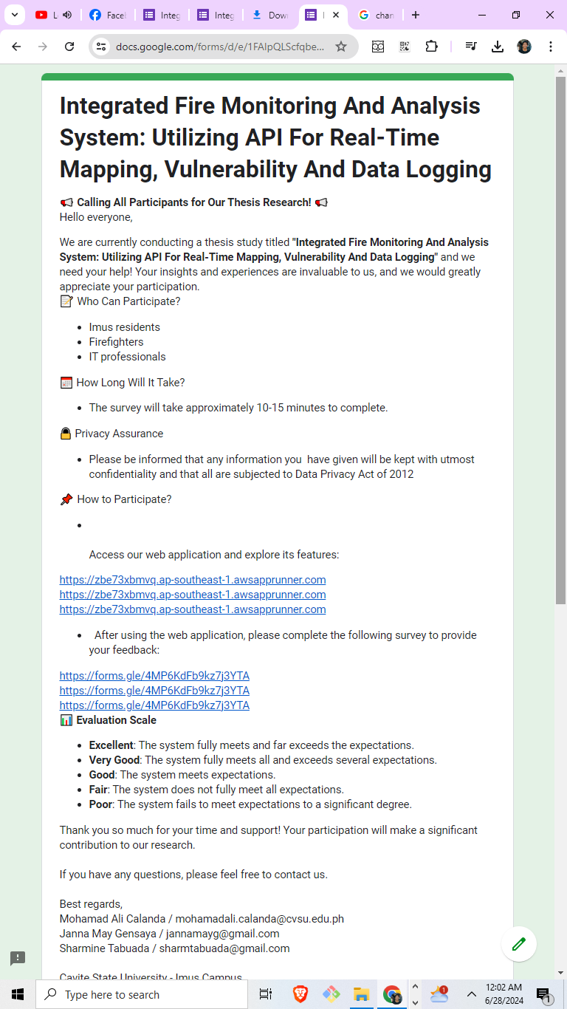

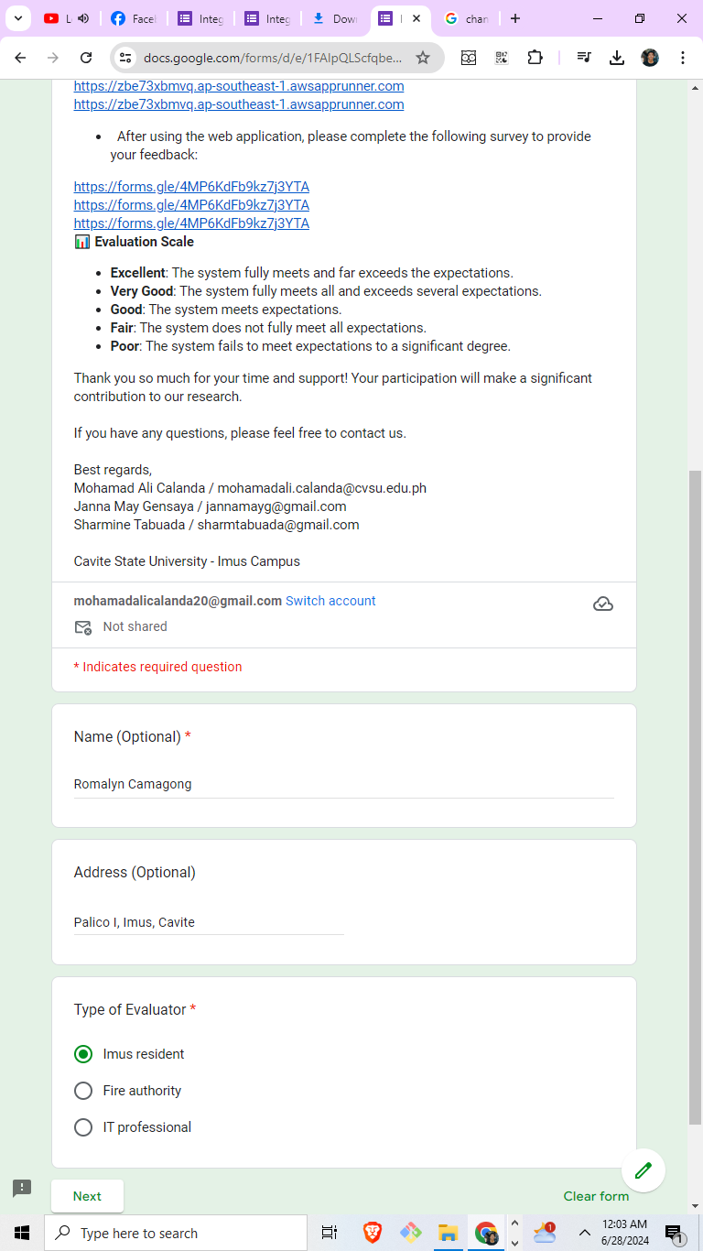



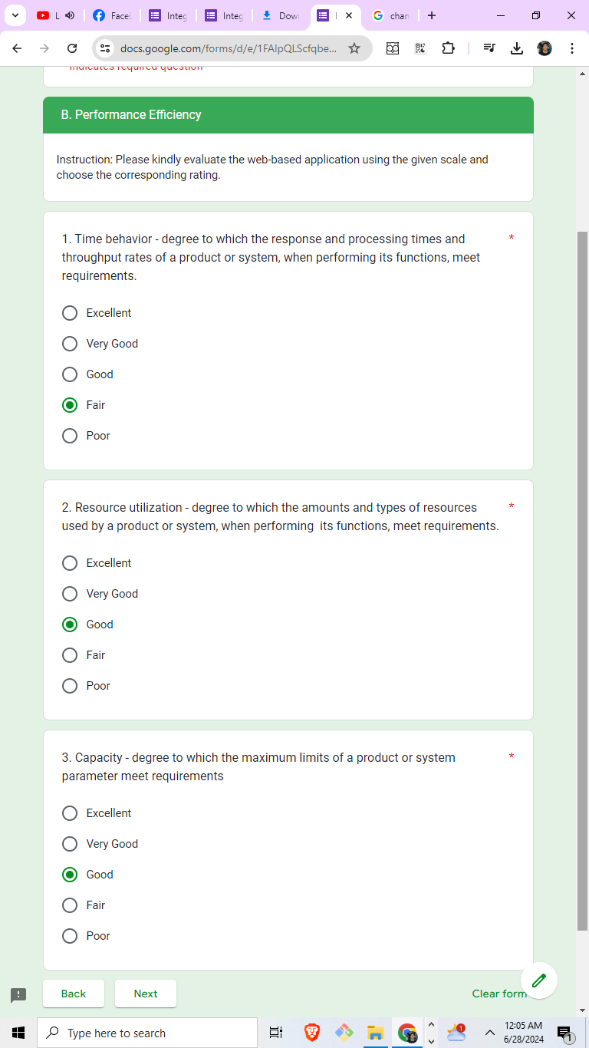

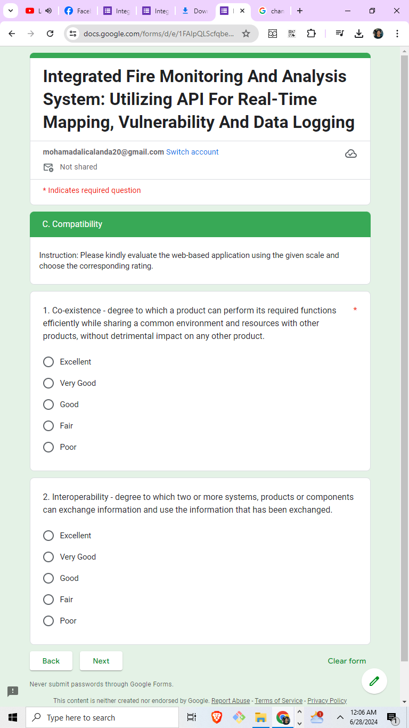

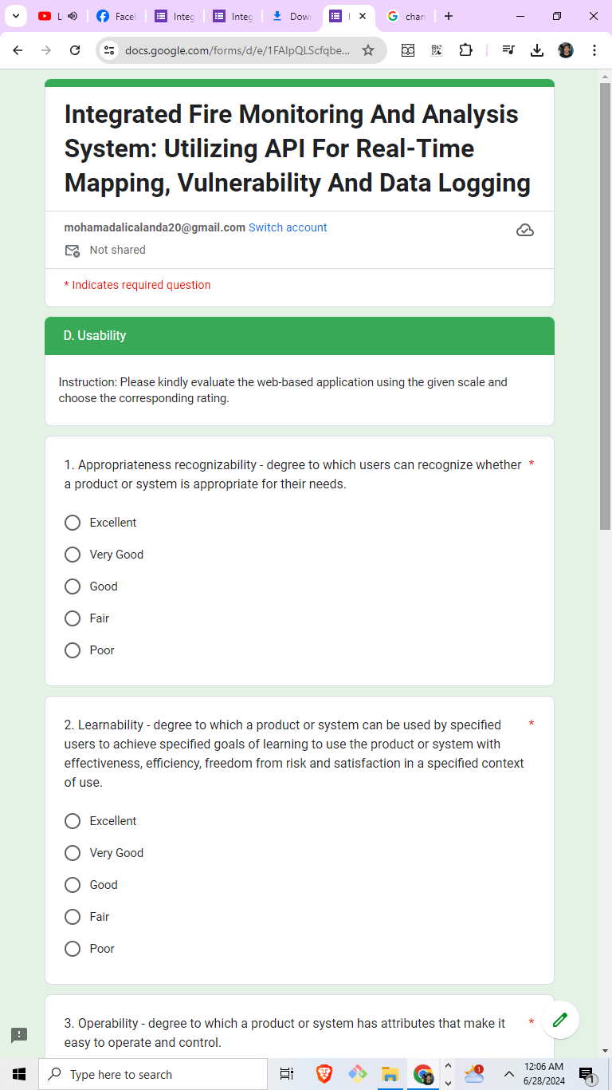

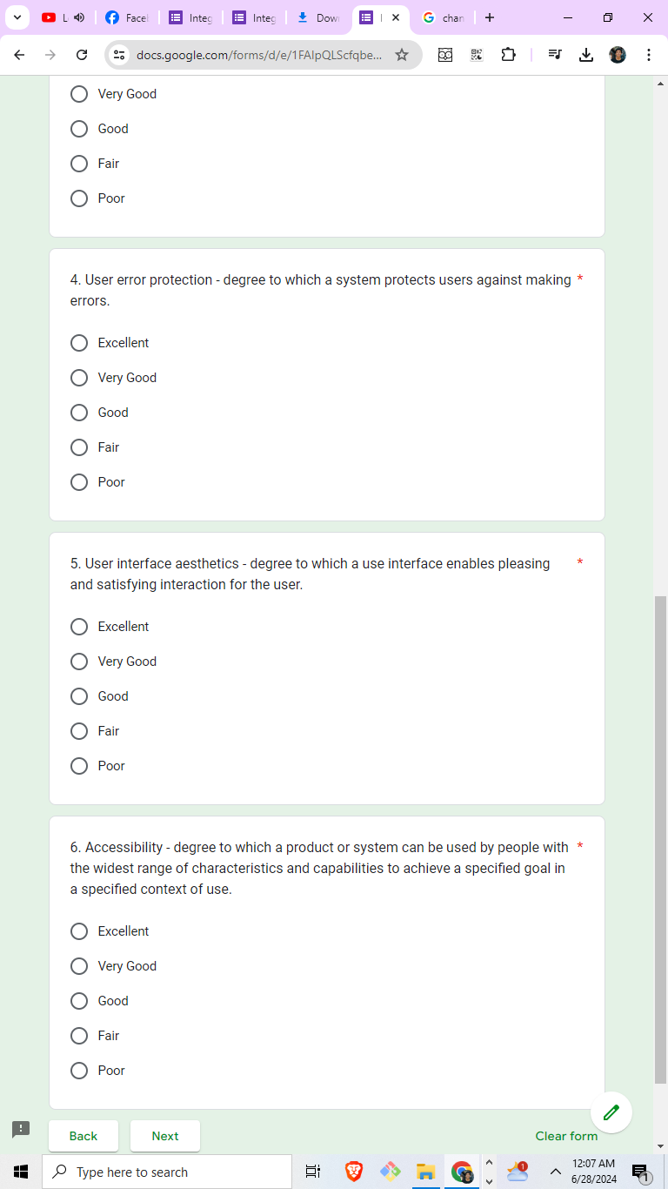

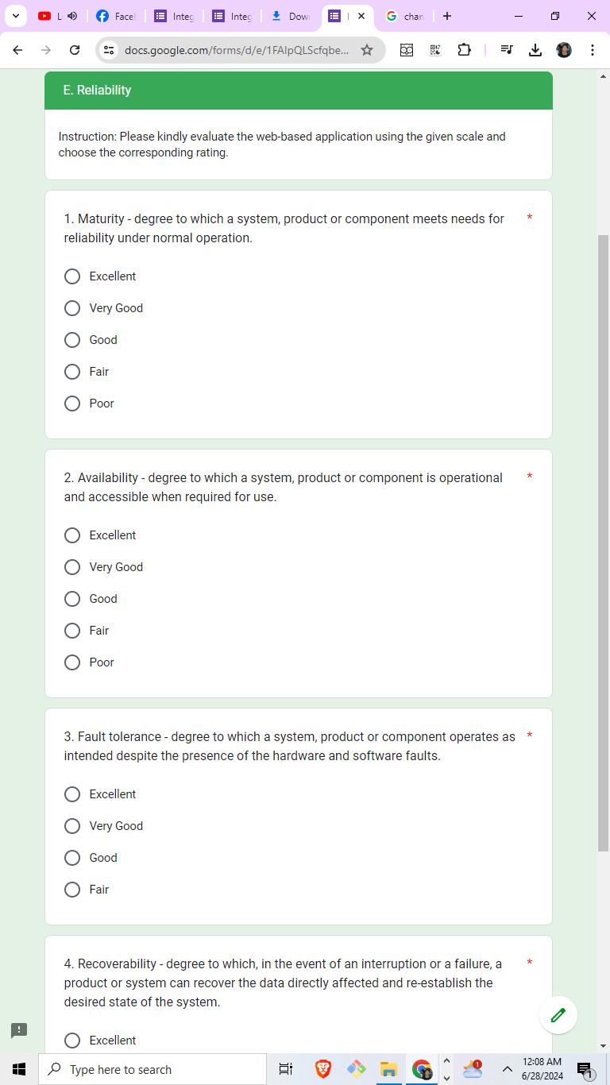

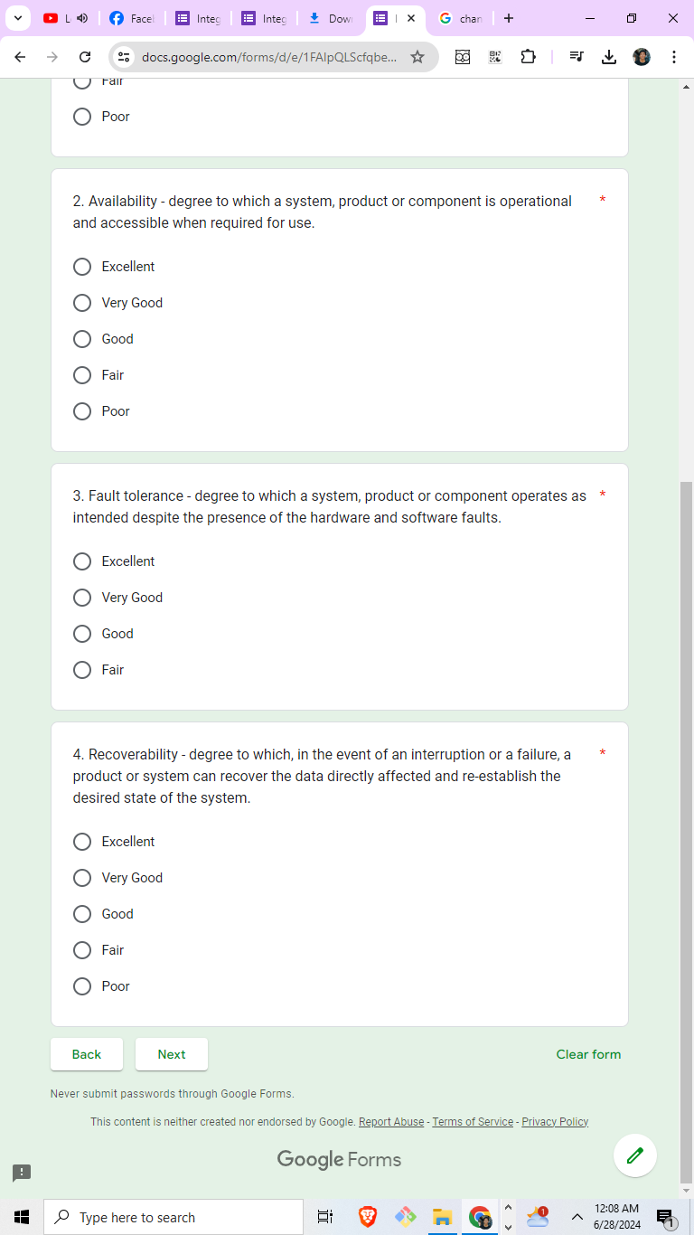

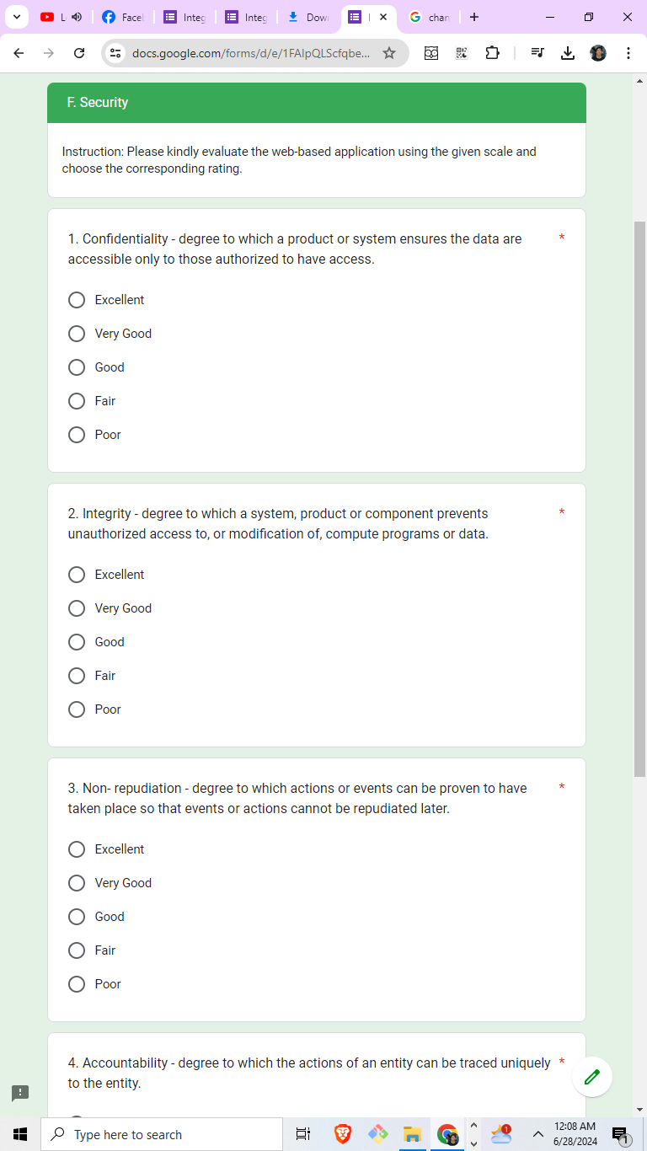

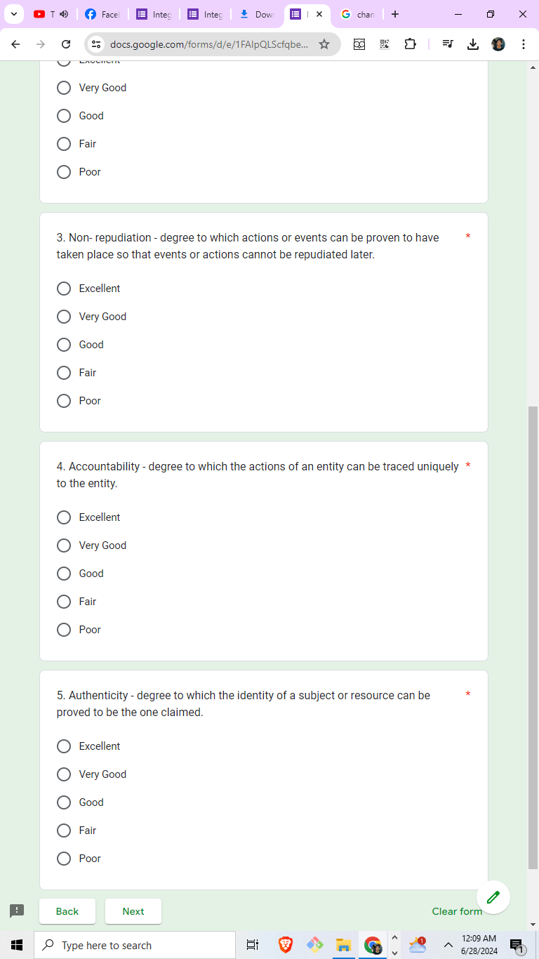

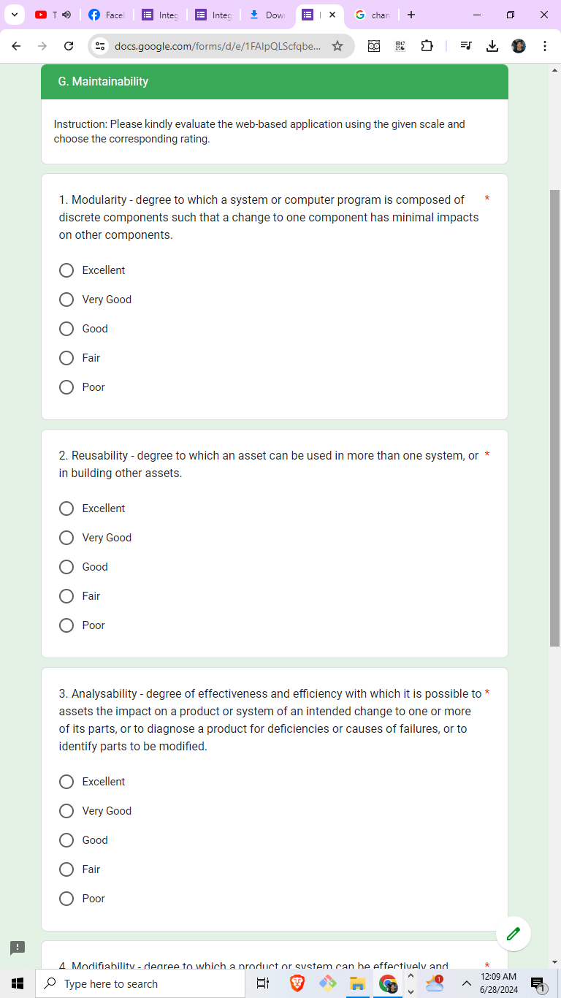

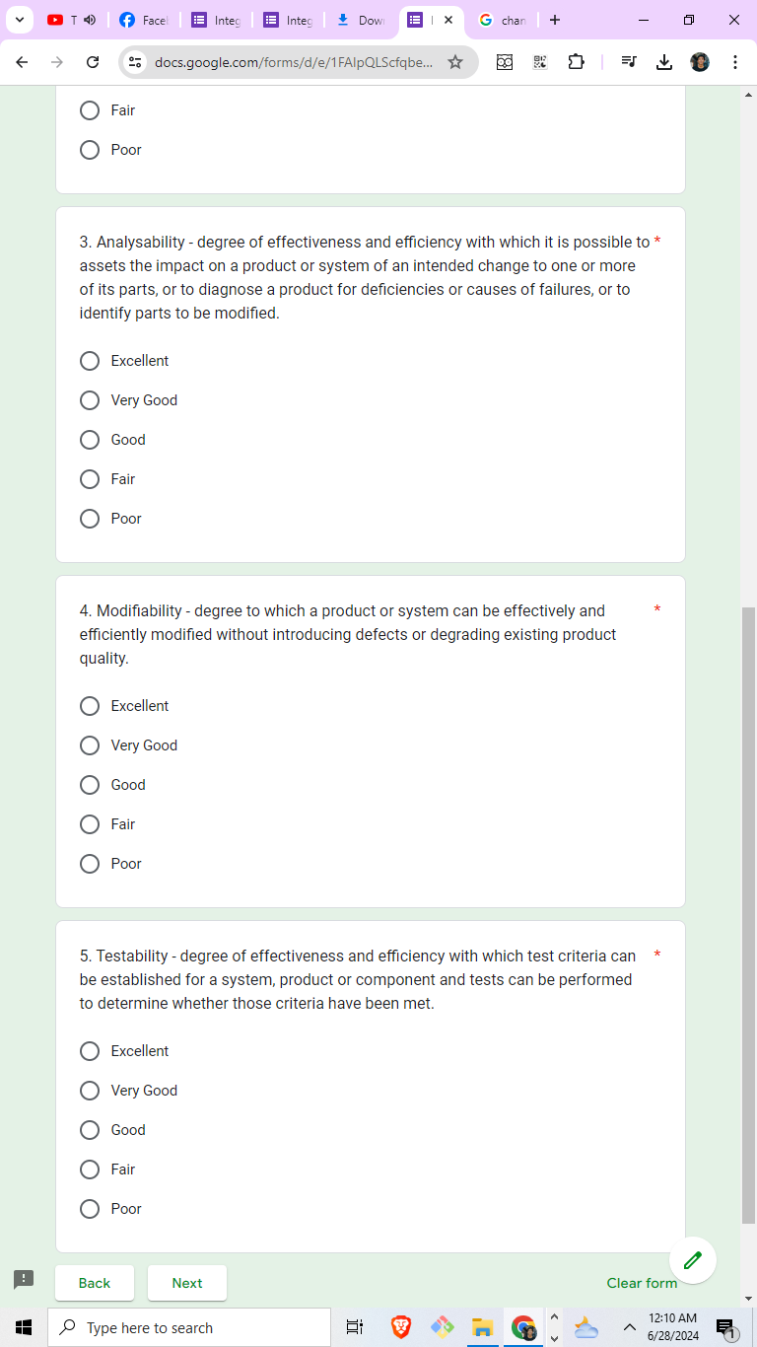

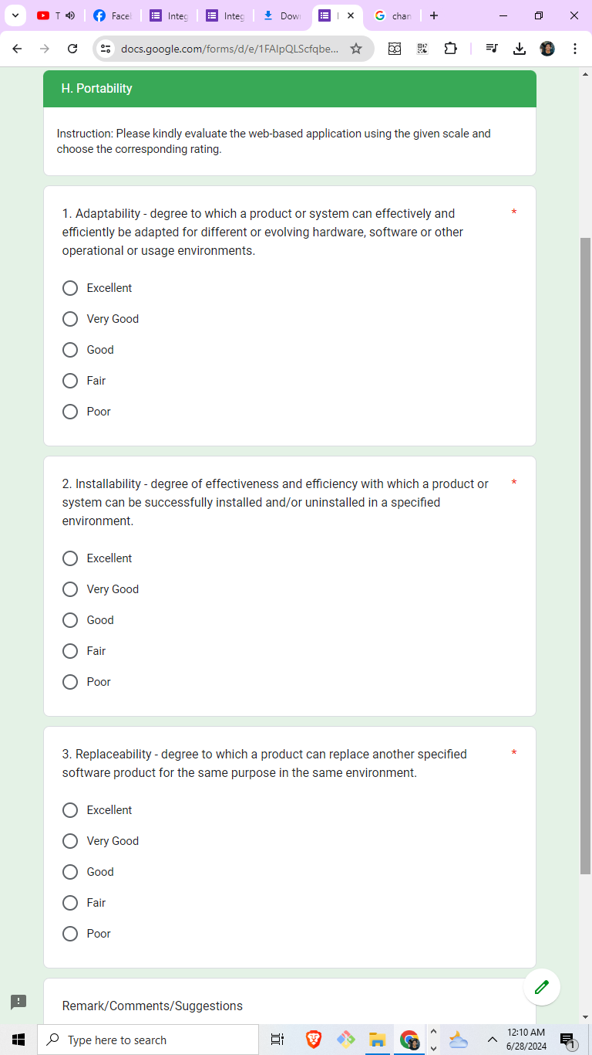

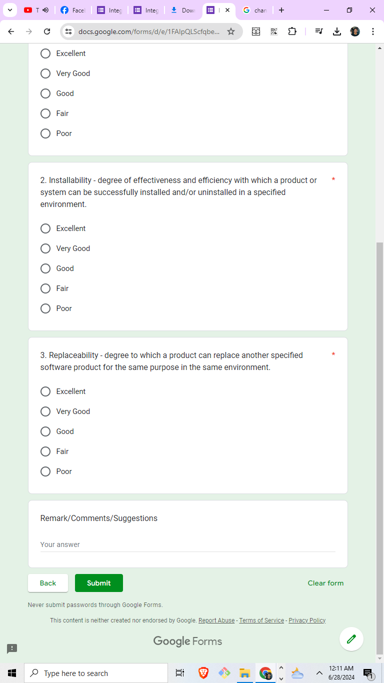

**Appendix 8:** System User Interface Desktop

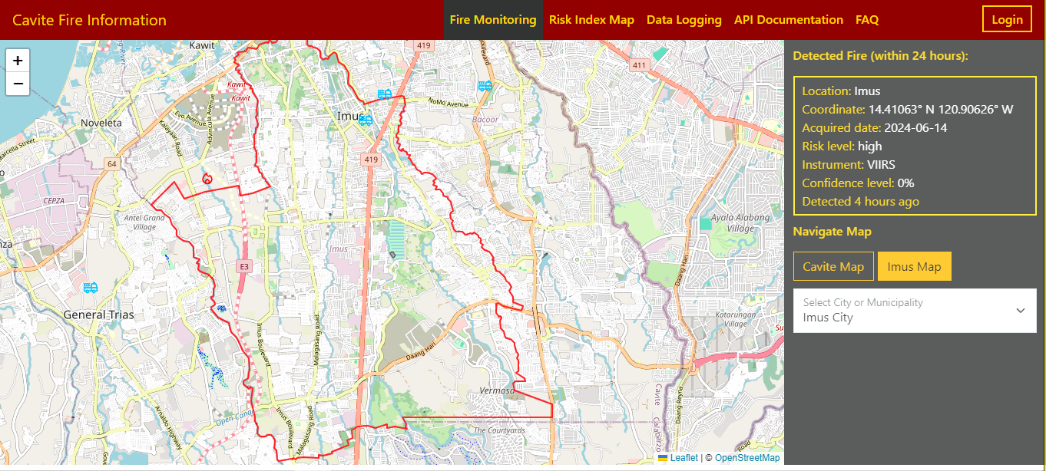

**Figure 3.** Fire Monitoring Page

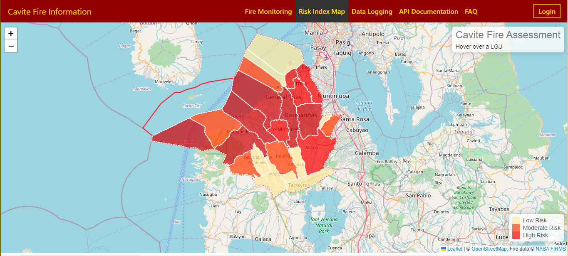

**Figure 4.** Risk Index Map Page

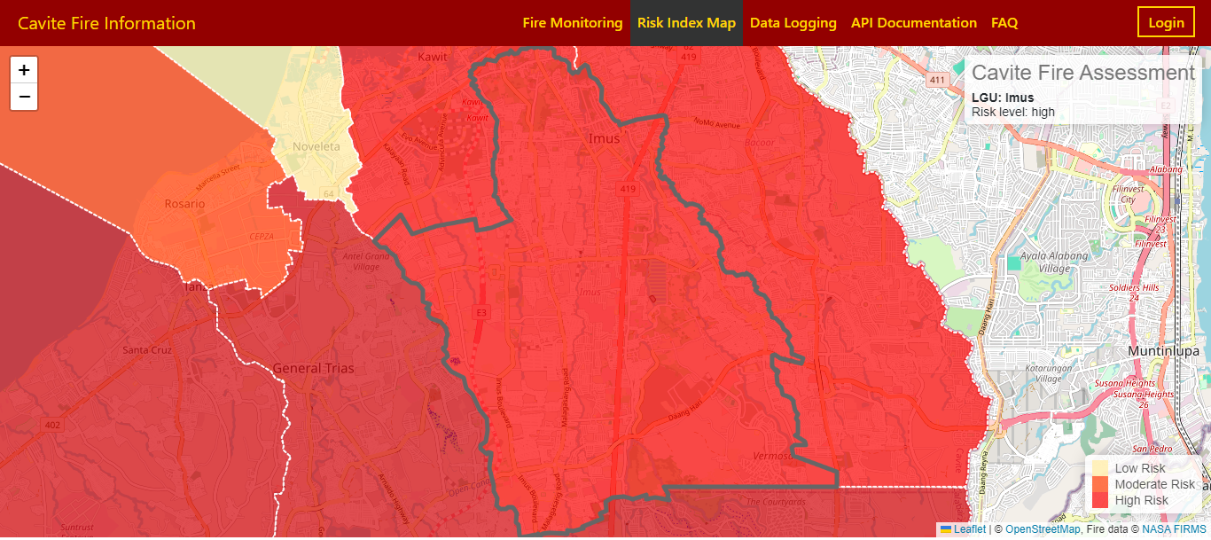**Figure 5.** Risk Index Map with zoomed-in map

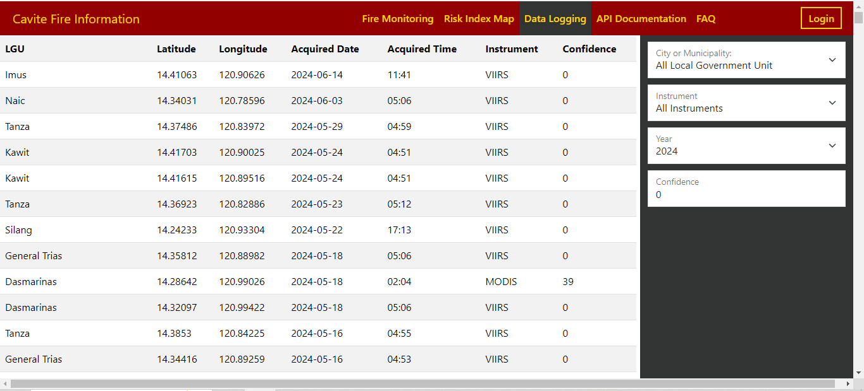

**Figure 6.** Data Logging Page without admin account logged in

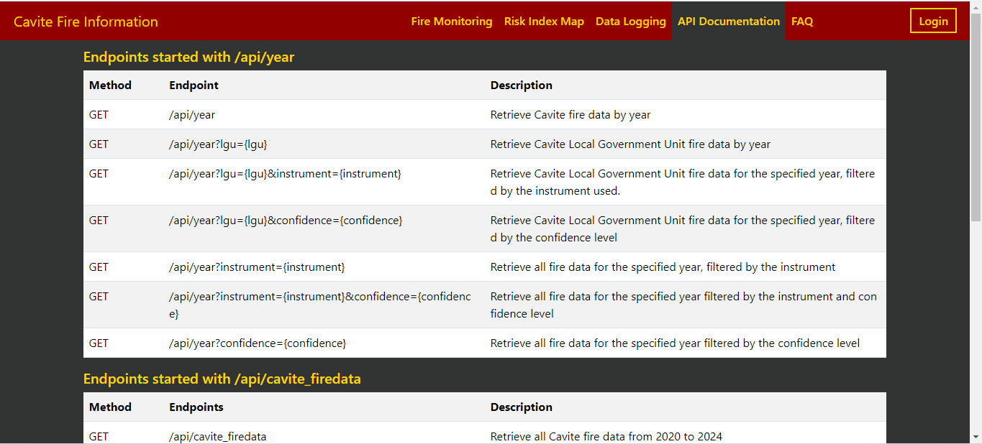

**Figure 7.** API Documentation Page

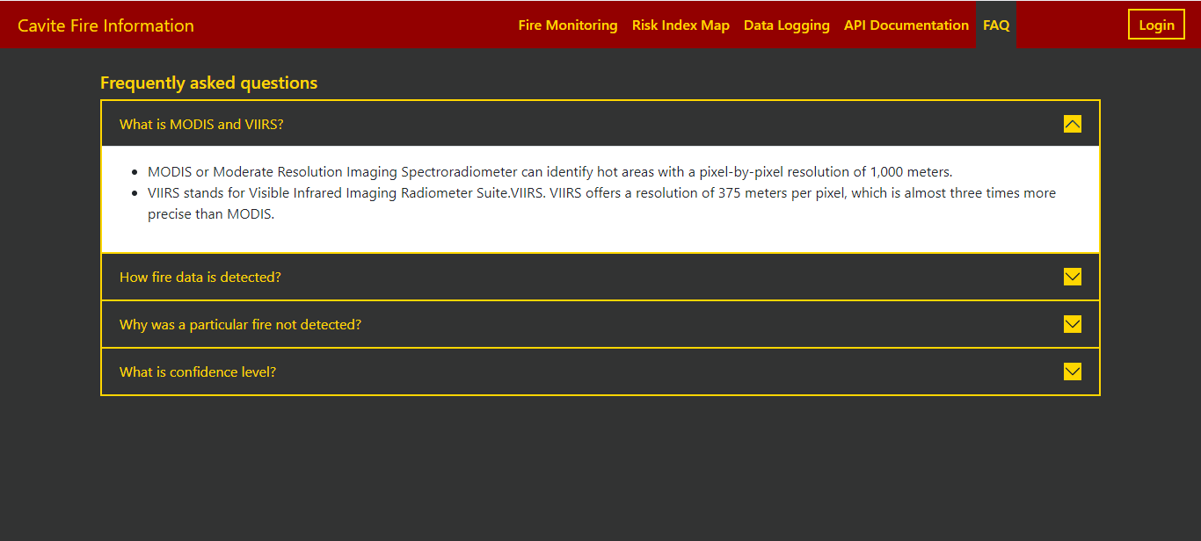

**Figure 8.** Frequently Asked Questions

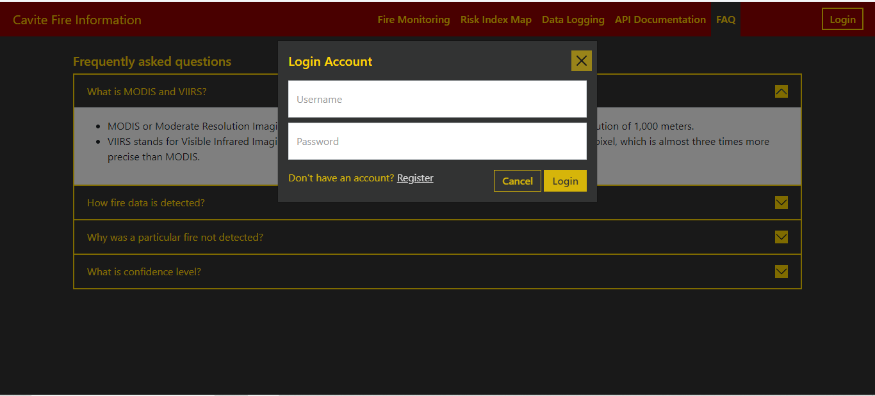

**Figure 9.** Login Modal

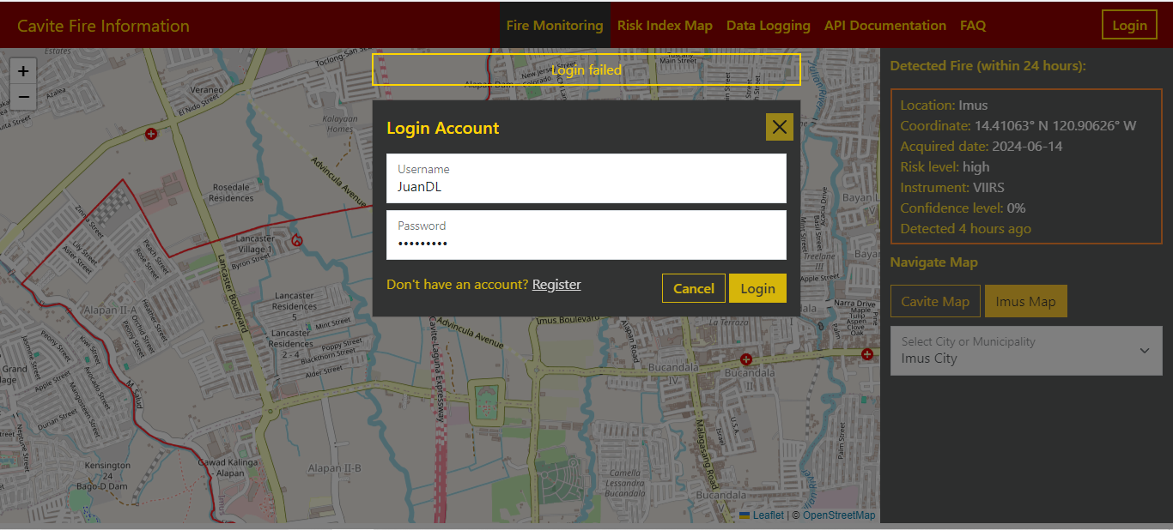

**Figure 10.** Login Modal with login failed message

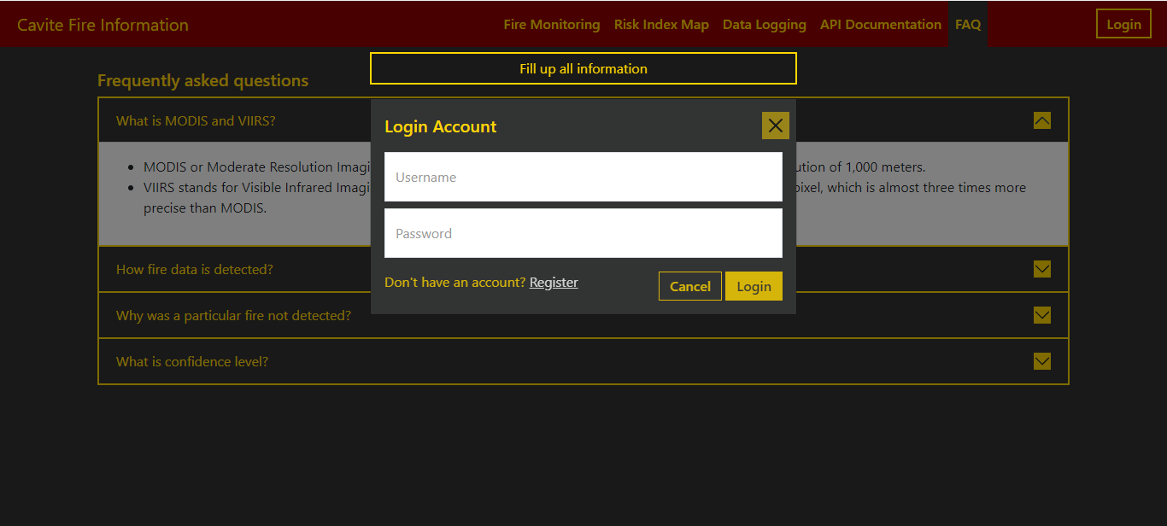

**Figure 11.** Login Modal with fill up all information message

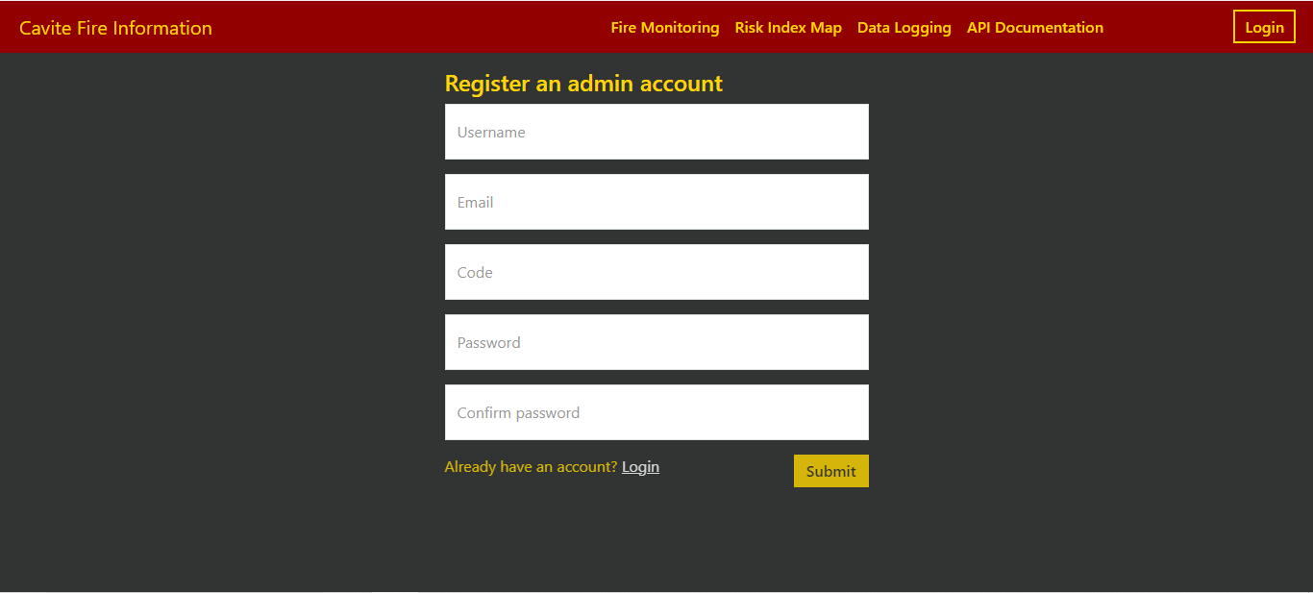

**Figure 12.** Register Page

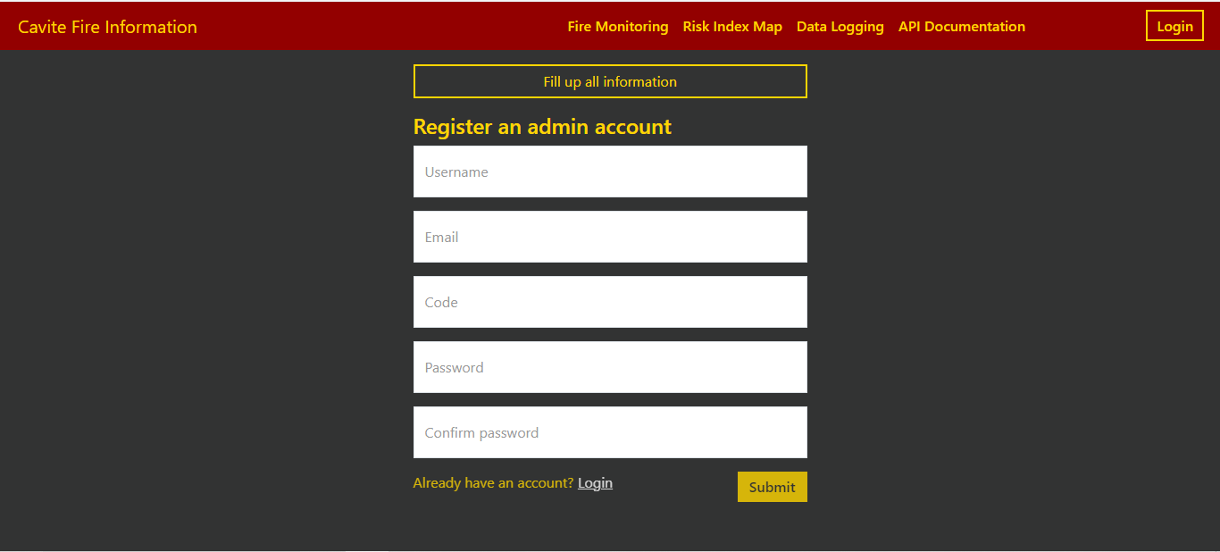

**Figure 13.** Register Page with fill up all information message

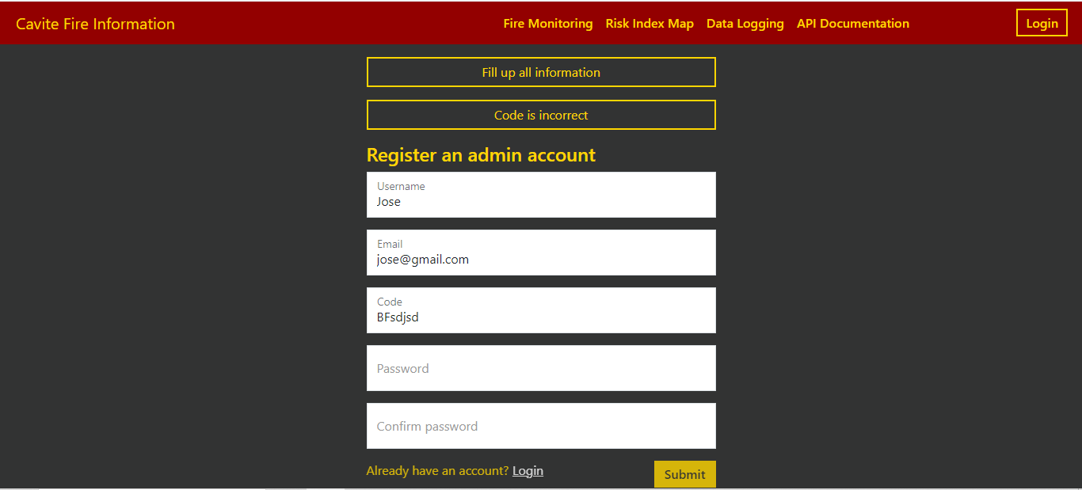

**Figure 14.** Register Page with code is incorrect message

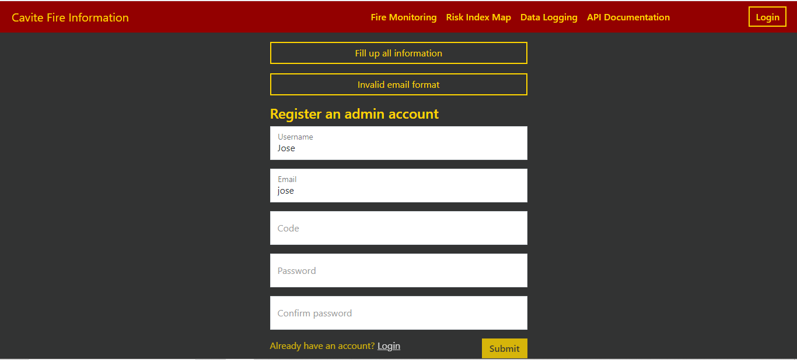

**Figure 15.** Register Page with invalid email format message

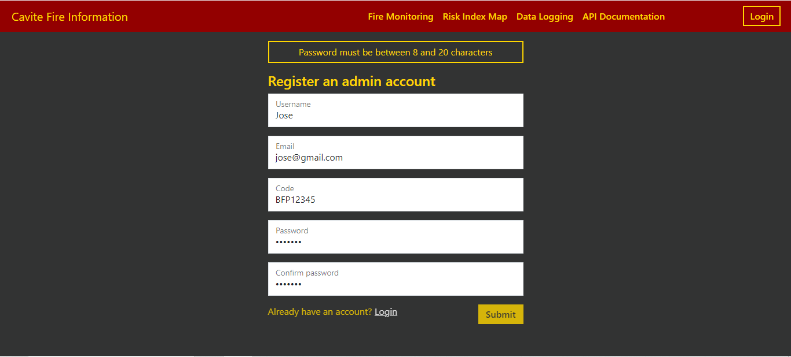

**Figure 16.** Register Page with password must be between 8-20 characters message

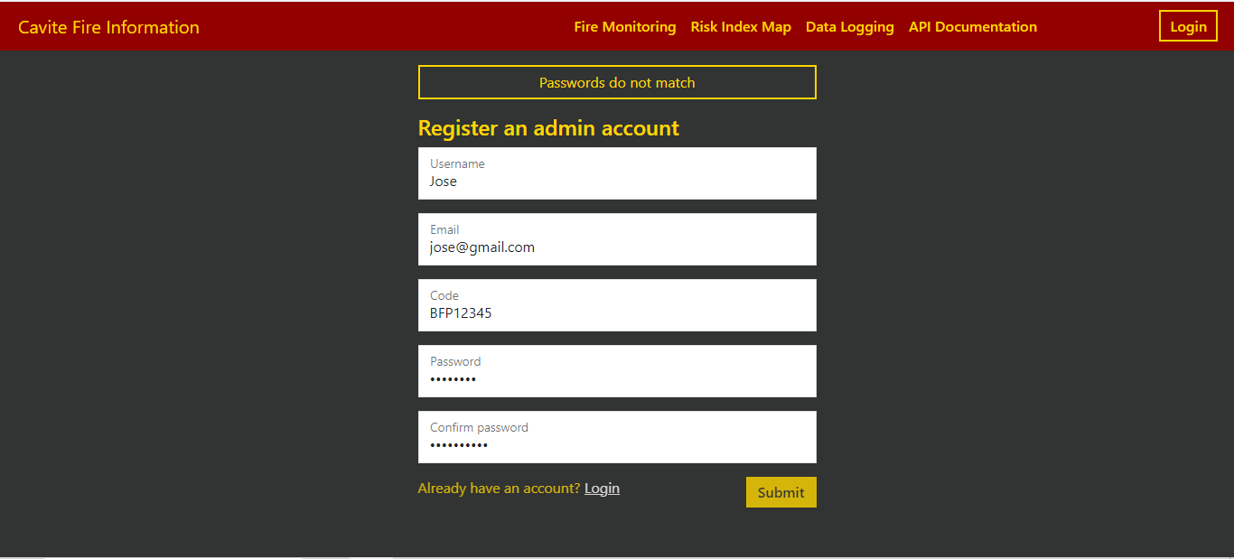

**Figure 17.** Register Page with passwords do not match

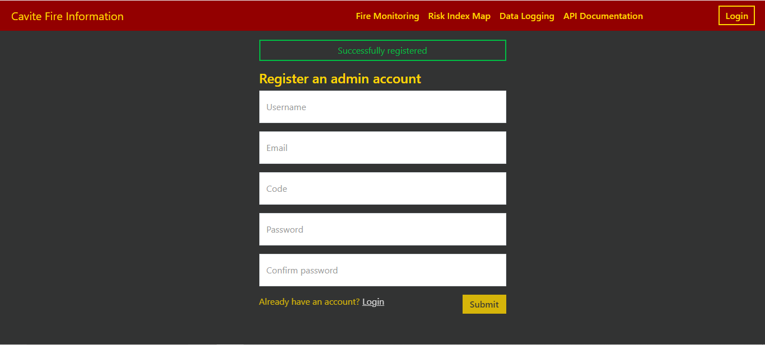

**Figure 18.** Register Page with successfully registered message

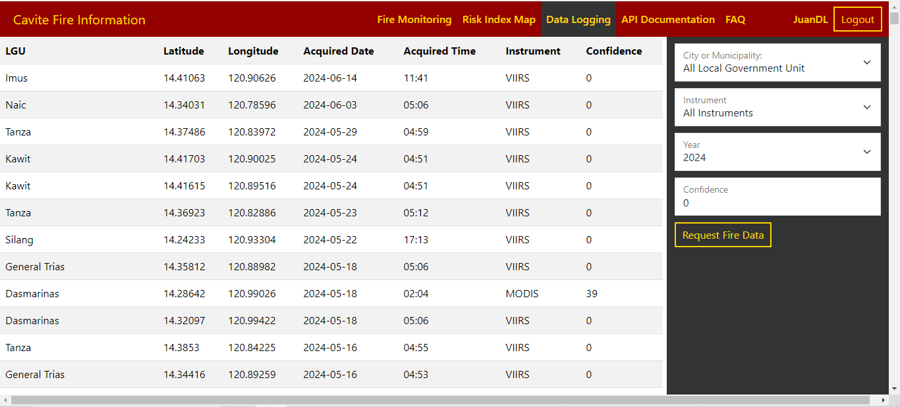

**Figure 19.** Data Logging Page with admin account logged in

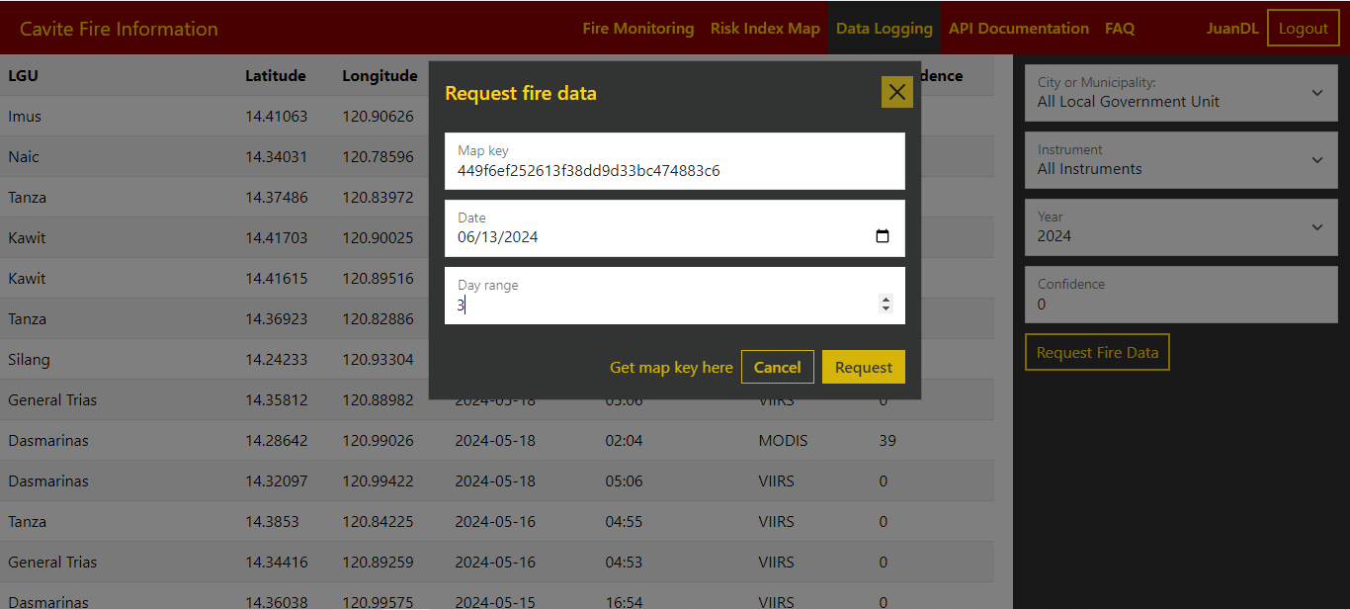

**Figure 20.** Request Fire Data Modal

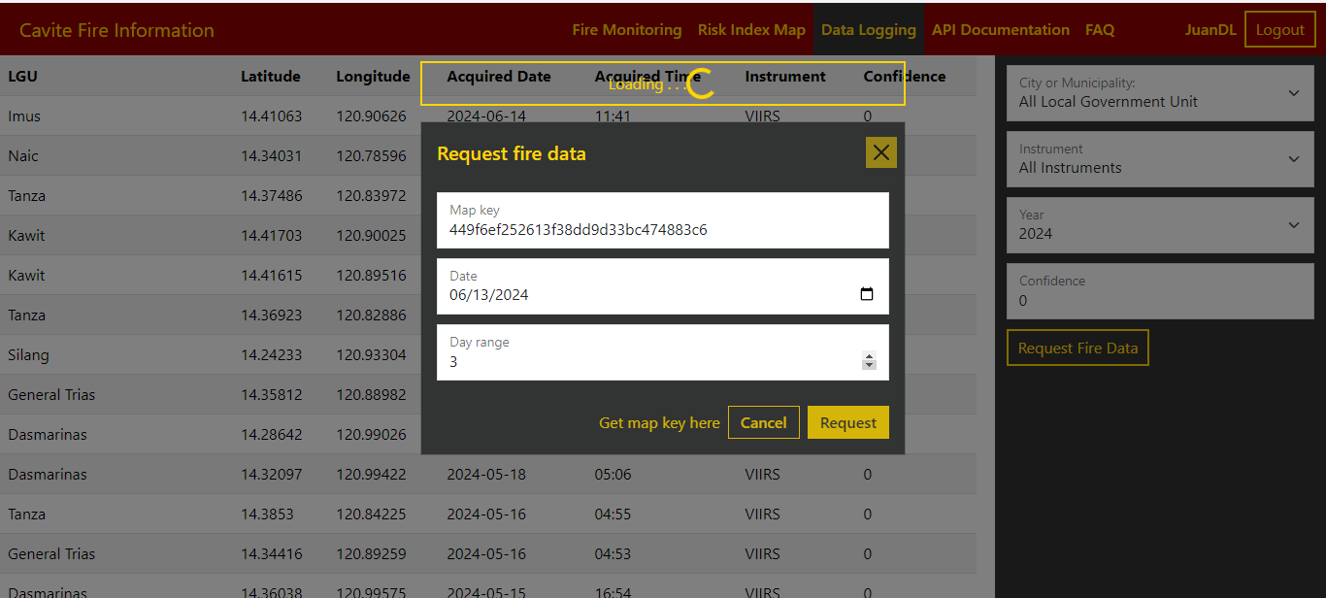

**Figure 21.** Request Fire Data Modal with loading message

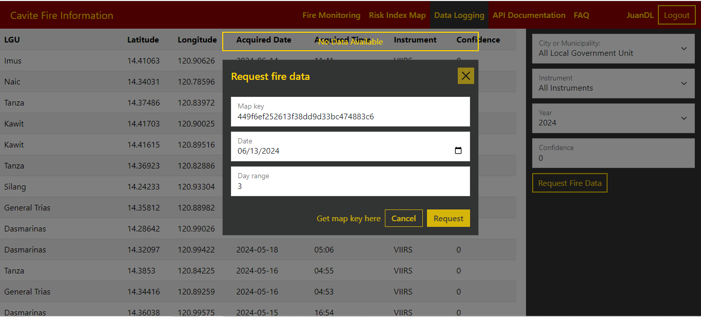

**Figure 22.** Request Fire Data Modal with no data available message